OP 3.2.2
RAPID PROTOTYPING AND MANUFACTURING

Version 2.0

This training course was developed within the framework of the implementation of the program of the European Commission Erasmus+ “Development of a Network Infrastructure for youth innovation entrepreneurship support on FabLab platforms” (561536-EPP-1-2015-1-UK-EPPKA2-CBHE-JP)
http://fablab-erasmus.eu/

The European Commission support for the production of this publication does not constitute an endorsement of the contents which reflects the views only of the authors, and the Commission cannot be held responsible for any use which may be made of the information contained therein.

Information about this document
Grant Agreement Number | 561536-EPP-1-2015-1-UK-EPPKA2-CBHE-JP |  |  | Acronym |  | FabLab
Full title | Development of a network infrastructure for youth innovation entrepreneurship support on FabLab platforms
Topic | ERASMUS+ CBHA
Start date | 15 October 2015 | Duration |  |  | 36 months
Project URL | http://fablab-erasmus.eu/
Project Coordinator | Dr. Dorin Festeu, Buckinghamshire New University, United Kingdom
Work Package | WP3 – TRAINING COURSES DEVELOPMENT
Project Coordinator | BNTU (P8) |  | Email | vtrepachko@bntu.by
 |  |  | Phone | +375 29 190 95 95
 |  |  | Skype address | vmtrepachko
Responsible Author
Reviewer(s): | All partners
Keywords | Rapid prototyping, Additive manufacturing technologies, Materials for additive manufacturing, Diagram of additive manufacturing processes, Components of FDM 3D printers, Quality of 3D printing

Document History
Version | Issue Date | Stage | Changes | Contributor
1.0 | 10/09/2017 | Draft | Course content (preparing the first course version) (1st level check) | P12 (IASA NTUU “KPI”)
2.0 | 05/10/2017 | Draft | Preparing the second course version (2nd level check) | BNTU

Contents
Course description 4
Learning outcomes 4
Course contents 4
Recommended literature 5
Planned teaching activities and teaching methods 6
Methods, criteria and procedure for evaluation 7
Skills and personal development 7
1. Milling and laser cutting technologies 8
2. Additive manufacturing technologies 9
3. Differences between AM and processing on CNC machines 12
4. Examples of additive manufacturing products 14
5. Materials for additive manufacturing 16
6. Diagram of additive manufacturing processes 18
7. Applications of AM 19
8. Advantages of additive manufacturing 20
9. Components of 3D printers using FDM technology 22
10. The factors that affect the quality of 3D printing 26

Course description
Course title: | Rapid prototyping and manufacturing
Course unit code | Rapid prototyping and manufacturing
University delivering the course: | BNTU, BSU, KhNUE, IASA NTUU “KPI”, TNTU
Course type | Optional
Course level | Master
Number of ECTS credits | 3 credits
Mode of delivery | lectures, practical lessons, seminars, individual word, distance learning
Prerequisites and co-requisites: | students, who can sign for this course, should have the bachelor’s degree in engineering or computer areas

Learning outcomes
Learning objectives:
familiarize students with the basic technologies of rapid manufacturing of models and their elements using various equipment;
prepare students for the application of modern rapid manufacturing technologies for solving practical scientific and technical problems;
provide students with the detailed knowledge of ​​the equipment and materials used in additive manufacturing, familiarize them with the diagram of additive manufacturing processes;
familiarize students with the components of 3D printers using FDM technology, and factors that affect the quality of 3D printing.
develop design skills and creativity among students.

As a result of successful mastering of the course, the student should know:
the basic technologies of rapid manufacturing of models and their elements;
technical devices and equipment for rapid prototyping;
materials and diagram of additive manufacturing processes, application areas and advantages of additive manufacturing;
the main components of 3D printers using FDM technology;
factors that affect the quality of 3D printing.

Course contents
1. Milling and laser cutting technologies
2. Additive manufacturing technologies
3. Differences between AM and processing on CNC machines
4. Examples of additive manufacturing products
5. Materials for additive manufacturing
6. Diagram of additive manufacturing processes
7. Applications of AM
8. Advantages of additive manufacturing
9. Components of 3D printers using FDM technology
10. The factors that affect the quality of 3D printing

Recommended literature
Main:
Гибсон, Ян. Технологии аддитивного производства / Я. Гибсон, Д. Розен, Б. Стакер ; пер. с англ. И. В. Шишковского. – М.: Техносфера, 2016. - 646 с.
Поляков, А.Н. Основы быстрого прототипирования / А. И. Сердюк, К. С. Романенко, И. П. Никитина, А. Н. Поляков .— Оренбург : ОГУ, 2014 - 128 с.
Валетов, В.А. Аддитивные технологии (состояние и перспективы). — СПб.: Университет ИТМО, 2015. — 63 с.
Абдус Салам. Доступная 3D печать для науки, образования и устойчивого развития (Low-cost 3DPrintingforScience, EducationandSustainableDevelopment). - МЦТФ (Отдел научных разработок), 2013. – 192 стр.
Зленко М.А. Аддитивные технологии в машиностроении / М.В. Нагайцев, В.М. Довбыш // пособие для инженеров. – М. ГНЦ РФ ФГУП «НАМИ», 2015. – 220 с.
Товажнянский, Л.Л. Интегрированные технологии ускоренного прототипирования и изготовления / Товажнянский Л.Л., Грабченко А.И., Чернышов С.И., Верезуб Н.В., Витязев Ю.Б., Доброскок В.Л., Кнут Х., Лиерат Ф. – Х.: Модель Вселенной, 2005. - 224 с.

Additional:
Зленко, М.А. Аддитивные технологии в машиностроении / Зленко М.А., Попович А.А., Мутылина И.Н. – СПб: СПбГУ, 2013. - 221 с.
Интегрированные генеративные технологии : учеб. Пособие [для студ. выс. учеб.заведений] / А. И. Грабченко, Ю. Н. Внуков, В. Л. Доброскок [и др.] ; под ред. А. И. Грабченко. – Харьков : НТУ «ХПИ», 2011. – 416 с.
В.И.Слюсар Фаббер-технологии: сам себе конструктор и фабрикант. - Конструктор 2001, №1. – с. 5-7.
М.Зленко Технологии быстрого прототипирования - послойный синтез физической копии на основе 3D-CAD-модели. - CAD/CAM/CAEObserver #2 (11) 2003. – с. 5-9.
В.Кузнецов Системы быстрого изготовления прототипов и их расширения. - CAD/CAM/CAEObserver, №4 (13) 2003. – с. 2-7.

Internet materials:
http://osvarke.com/gidroabrazivnaya-rezka.html
https://youtube.com/watch?v=4IKlR76oflc
http://lincolnelectric.com/ru-ru/support/process-and-theory/Pages/how-a-plasma-cutter-works.aspx
http://svarkainfo.ru/rus/technology/rezka/vprez/
http://svarkaland.ru/ctati/plazmennaya-rezka-i-ee-osobennosti
http://gigamech.com/info-mmi/articles-mmi/92-lazer-vs-plasma
http://ostanke.ru/chpu/frezernaya-rezka-fanery.html
https://books.google.es/books?id=8Mp3CwAAQBAJ&hl=ru&num=13
http://3dtoday.ru/wiki/3D_print_technology/
https://rb.ru/longread/3D-cards/
Технологии быстрого прототипирования http://laser.ru/rapid/index.htm
http://orgprint.com/novosti/idtechex-tendencii-razvitija-rynka-rashodnyh-materialov-dlja-3d-pechati
http://stepconsulting.ru/advices/materialy-dlya-3d-printerov-chto-segodnya-ispolzuyut-dlya-3d-pechati
https://3dsmart.com.ua/blog/sfery-primeneniya-3d-pechati
http://3dtoday.ru/blogs/54e18bfe8e/what-you-print-examples-of-the-use-of-3d-printing-in-medicine/
http://terem.ru/catalog/3D-PRINT/3D-Technologies-Applications/
https://geektimes.ru/company/top3dshop/blog/280098/
http://3dtoday.ru/wiki/FDM_printers/#.D0.9A.D0.BE.D0.BD.D1.81.D1.82.D1.80.D1.83.D0.BA.D1.82.D0.B8.D0.B2.D0.BD.D1.8B.D0.B5.D1.8D.D0.BB.D0.B5.D0.BC.D0.B5.D0.BD.D1.82.D1.8B2
http://3dtoday.ru/wiki/3D_print_technology/
http://techno-guide.ru/informatsionnye-tekhnologii/3d-tekhnologii/kak-rabotaet-3d-printer-printsip-raboty-trekhmernoj-pechati.html
http://3dpr.ru/printsip-raboty-3d-printera
http://orgprint.com/wiki/3d-pechat/Klassifikacija-3D-printerov-po-osjam-dvizhenija-jekstrudera-i-platformy
http://ixbt.com/printer/3d/3d_fdm.shtml
https://3dnews.ru/peripheral/3d-print/print
https://3dpt.ru/page/soft
https://habrahabr.ru/post/196182/
https://3deshnik.ru/blogs/akdzg/obzor-osnovnyh-nastroek-slajsera-cura
http://3dtoday.ru/blogs/3dpicasso/cura-your-caring-assistant-in-the-world-of-printing-part-1/
https://3deshnik.ru/blogs/akdzg/sekrety-slajsera-cura-chast-1
https://3deshnik.ru/blogs/akdzg/sekrety-slajsera-cura-chast-2
https://3deshnik.ru/blogs/akdzg/sekrety-slajsera-cura-chast-3
https://3deshnik.ru/blogs/akdzg/cura-optimizatsiya-nastroek-retrakta
http://support.3dverkstan.se/article/30-getting-better-prints
http://3dtoday.ru/blogs/rec/how-to-print-flexible-materials-in-conventional-fdm-printer-educationa/
https://3dpt.ru/page/faq

Planned teaching activities and teaching methods
Practical training of students is suggested, which is implemented through:
1. Discussion of projects.
2. Organization of projects proposed by students.
3. Mutual learning.
4. Self-assessment and assessment by fellow students.
5. Invited lecturers.
6. Group discussions, reviews and critical evaluations.
7. Work on real projects.
8. Mentoring.
9. Self-education.

For flexible learning:
The teacher conducts webinars, which represent the methodology and the conceptual base for students' education. Slides and course materials are available electronically. Webinars are used to strengthen knowledge of new methods and approaches, as well as to study their application in specific complex situations. Students are invited to ask questions and discuss materials in the real time online communication. To organize communications, an internet forum (message board) is used. Students can post questions and the teacher will monitor these discussions. The main emphasis is on independent learning.

Methods, criteria and procedure for evaluation
Progress and training are assessed not only at the end, but throughout the course. The ability to think and analyze problems will be assessed.
Students’ grades will be determined through reports on individual assignments after each section with a presentation of prototypes. The relative weight of each report will be set at 100%, and, in addition, the weight of the evaluation will include:
description – 20 %;
the analysis of mistakes during modeling or tuning of models – 30 %;
use of adequate terminology – 10 %;
availability of a working prototype – 40 %.

Skills and personal development
The course provides the ability of students:
prepare and set up the equipment for the manufacture of models, layouts, or their elements;
choose the material for the model;
make a model, a layout, or their element.
Use the gained knowledge to solve practical scientific and technical problems.

- Milling and laser cutting technologies
Milling and cutting shape the object by removing the excess material.
In essence, milling and cutting are the total opposite of 3D-printing.
Currently, several main types of small-scale production are distinguished:
- sandblasting;
- milling cutting;
- plasma cutting;
- laser engraving / cutting.
Sandblasting is a technology in which the surface of a workpiece is damaged by a jet of sand or other abrasive material sprayed with airflow in the case of cold treatment and a jet of liquid containing abrasive and emitted at supersonic speed in the case of hydroabrasive processing.
Milling cutting is cutting using a tool with one or more cutting blades (milling cutters) of flat and shaped surfaces, cog wheels, etc. of metal and other blanks. In this case, the milling cutter fixed in the spindle of the milling machine performs rotational (main) movement, and the workpiece fixed to the table makes the feed motion straight or curved.
CNC plasma cutting machines provide high speed and quality of cutting, which can take place in the oxygen environment, but are most often applicable only to electrically conductive materials.
Currently, laser cutters are gaining popularity which are production tools designed for prototyping and used by engineers, designers and artists, due to ease of application and low cost (Figure 3.1). Laser cutters use a thin, focused laser beam to pierce and cut the materials. In addition to cutting, laser cutters can also rasterize or etch designs on blanks, heating their surface, thereby burning the upper layer of the material to change its appearance, where the raster operation was performed.
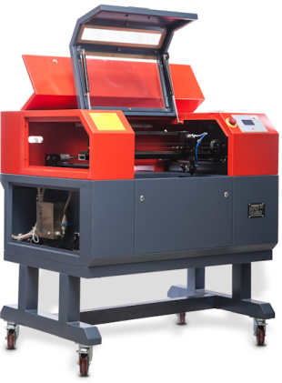
Figure 3.1 – Laser cutter

All these cutters are machines for rapid prototyping. Some of them allow you to quickly and some of them quickly and cheaply do iterations to improve the design before moving to a large-scale production.
Additional information:
http://osvarke.com/gidroabrazivnaya-rezka.html
https://youtube.com/watch?v=4IKlR76oflc
http://lincolnelectric.com/ru-ru/support/process-and-theory/Pages/how-a-plasma-cutter-works.aspx
http://svarkainfo.ru/rus/technology/rezka/vprez/
http://svarkaland.ru/ctati/plazmennaya-rezka-i-ee-osobennosti
http://gigamech.com/info-mmi/articles-mmi/92-lazer-vs-plasma
http://ostanke.ru/chpu/frezernaya-rezka-fanery.html
https://books.google.es/books?id=8Mp3CwAAQBAJ&hl=ru&num=13

- Additive manufacturing technologies
Term “Rapid Prototyping” (RT) is used in various industries to describe the process of rapid manufacturing of the model, the layout of the system or part of it before it is finally put into production or commercialized. In other words, the emphasis is on quickly creating a prototype or basic model, on the basis of which it would be possible to further develop more accurate models and eventually obtain the final product.
Improving product quality, developing methods of 3D printing and equipment for RT led to the understanding that this term did not fully represent the later applications of the technology.
Created by ASTM (American Society for Testing and Materials), the technical committee decided to introduce the new terminology. Although this decision is still under discussion, the term “Additive Manufacturing” is used in the accepted ASTM standards.
In various works, a number of equivalent terms by meaning can be found: Additive Fabrication (AF), Additive Processes, Additive Techniques, Additive Layer Manufacturing, Layer Manufacturing, Freeform Fabrication. In the domestic practice, the terms "additive technologies" or AF-technologies are most widely used, although the term "additive production technology" is more precise.
Additive fabrication (AF) involves the fabrication (construction) of a physical object (part) by the method of layer-by-layer deposition (addition) of the material. If in the traditional production at the beginning we have a workpiece, from which we then cut off all unnecessary, or deform it, then in the case of additive production, a new product is built from nothing (or rather, from amorphous consumables). Depending on the technology, the object can be built from bottom to top or vice versa, to obtain different properties, etc.
Today we can distinguish the following additive production technologies:
FDM (Fused deposition modeling) — layered construction of a product made of molten plastic filament. This is the most common method of 3D printing in the world, on the basis of which millions of 3D printers work - from the cheapest to industrial 3D printing systems. FDM printers work with different types of plastics, the most popular and affordable of which is ABS. Plastic products are highly durable, flexible, perfectly suited for product testing, prototyping, as well as for the manufacture of ready-to-use objects. The world's largest manufacturer of 3D plastic printers is American company Stratasys.

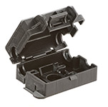 |  | 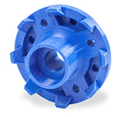
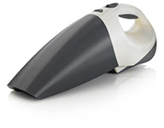 |  | 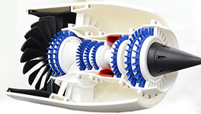

SLM (Selective laser melting) — selective laser melting of metallic powders. This is the most common method of 3D printing with metal. With the help of this technology, it is possible to quickly produce complex geometric metal products, which in their properties are superior to casting and rolling. The main manufacturers of SLM-printing systems are German companies SLMSolutions and Realizer.

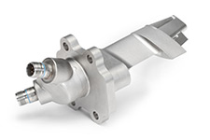 | 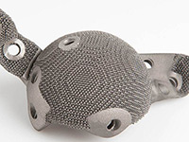 | 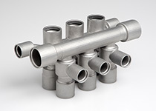

SLS (Selective laser sintering) — selective laser sintering of polymer powders. With the help of this technology it is possible to obtain large products with different physical properties (increased strength, flexibility, heat resistance, etc.). The largest manufacturer of SLS-printers is American company 3D Systems.

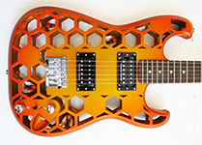 | 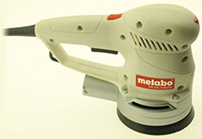
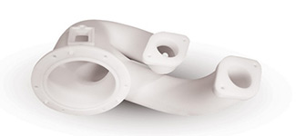

SLA (from Stereolithography) — laser stereolithography, curing of a liquid photopolymer material under the action of a laser. This technology of additive digital manufacturing is focused on the manufacture of high-precision products with different properties. The largest manufacturer of SLA-printers is American company 3D Systems.

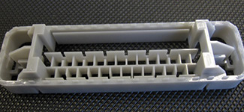
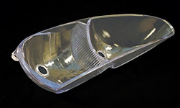 | 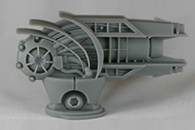

It is worth to define a separate category for the technology of rapid prototyping. These are 3D printing methods designed to obtain samples for visual evaluation, testing, or master models for creating casting molds.
MJM (Multi-jet Modeling) — is multi-jet modeling with a photocurable plastic resin or wax material. This technology makes it possible to produce burnable or meltable master models for casting, as well as prototypes of various products. It is used in ProJet series 3D-printers made by company 3DSystems.
PolyJet – curing of a liquid photopolymer under the influence of ultraviolet radiation. It is used in Objet 3D-printers of American company Stratasys. The technology is used to manufacture prototypes and master models with smooth surfaces.
CJP (Colorjet printing) – is layer-by-layer deposition of the adhesive on the powdered gypsum material. The technology of 3D printing with gypsum is used in 3D-printers ProJetx60 (previously called ZPrinter). Today it is the only industrial technology of full-color 3D-printing. It allows to produce bright colorful prototypes of products for testing and presentations, as well as various souvenirs, architectural models.
Additional information:
http://3dtoday.ru/wiki/3D_print_technology/
https://rb.ru/longread/3D-cards/
Зленко М.А. Аддитивные технологии в машиностроении / М.В. Нагайцев, В.М. Довбыш // пособие для инженеров. – М.: ГНЦ РФ ФГУП «НАМИ», 2015. – 220 с.
Интегрированные генеративные технологии : учеб. Пособие [для студ. выс. учеб.заведений] / А. И. Грабченко, Ю. Н. Внуков, В. Л. Доброскок [и др.] ; под ред. А. И. Грабченко. – Харьков : НТУ «ХПИ», 2011. – 416 с.
В.И.Слюсар Фаббер-технологии: сам себе конструктор и фабрикант. - Конструктор 2001, №1. – с. 5-7.
М.Зленко Технологии быстрого прототипирования - послойный синтез физической копии на основе 3D-CAD-модели. - CAD/CAM/CAEObserver #2 (11) 2003. – с. 5-9.
В.Кузнецов Системы быстрого изготовления прототипов и их расширения. - CAD/CAM/CAEObserver,№4 (13) 2003. – с. 2-7.
Технологии быстрого прототипирования http://laser.ru/rapid/index.htm

- Differences between AM and processing on CNC machines
AM processes have much in common with working on CNC machines. CNC technology also has a computer-based control, which is used to manufacture products. The manufacture of products on CNC machines differs mainly in that in the production process, material is removed, not added. For manufacturing on CNC machines, a workpiece larger than the part to be cut from it is required. Let's describe the main distinctive features in some categories.
Material
AM technology was originally developed for polymer materials, waxes and paper laminates. Subsequently, the introduction of composites, metals, ceramics into AM has begun. CNC machines can be used for soft materials, such as medium density fibreboard (hardboard), technological (machinable) foams and waxes and even certain polymers. Nevertheless, the use of CNC machines in processing softer materials is focused on the preparation of these parts for use in a multi-stage process, for example, in the casting of blanks. CNC machines are best used for final precise manufacturing of high-quality parts with specified characteristics from hard, but relatively brittle materials such as steel and other metal alloys. Some products made using AM, in contrast, have cavities and holes or anisotropy of properties that depend on the orientation of the product, the parameters of the production process, while products made on CNC machines have greater uniformity of properties and have more predictable quality parameters.
Processing speed
A high speed CNC machine is able to remove material much faster than AM machines can add layer by layer to a similar volume. Nevertheless, this is only part of the picture, since AM technology can only be used at one stage. CNC machines require considerable effort to adjust and plan the process, especially for the manufacture of parts of complex geometric shapes. Therefore, the speed should be evaluated from the point of view of the whole process, and not only the physical processing of the part. CNC machines are used in a multi-stage production process, during which you have to move or rearrange the part inside one installation or use different machines. It only takes a few hours to make a part using AM machine. Often several parts are manufactured in batches at one AM stage. Finishing can take several days, if high quality is required. The same machining process on a CNC machine, even on a 5-axis high-speed machine, can take several weeks, and the exact production time cannot be predicted in advance.
Complexity
The higher the complexity of the geometric shape is, the greater the advantage of AM is in comparison with the CNC. If the CNC machine is used to create a single piece at once, then there are cases when some geometric characteristics are simply impossible to produce. The installation of a machining tool on the spindle imposes certain restrictions on access to or contact with the part to avoid unplanned movement of the tool over the workpiece surface. AM processes do not have such limitations, so the removable and internal surfaces can easily be built up and completed without additional actions. Some parts cannot be manufactured on CNC machines, if they are not divided into components or require assembly at subsequent manufacturing stages. Consider, for example, the possibility of creating a model of a ship inside a bottle. On the CNC machine, both parts are separately made, and then they are connected. Thus, the mechanical engineer must analyze the design of each part before it is manufactured. Thanks to the use of AM, you can immediately build a ship in a bottle.
Precision
AM devices, as a rule, operate with a resolution of several tens of microns. A common rule for AM machines is a different resolution along each of the orthogonal axes. The vertical axis of the assembly corresponds to the thickness of the layer, so it will have a lower resolution than the two other axes in the assembly plane. The accuracy of CNC machines is mainly determined by a similar positioning resolution along the three axes and diameters of the rotating cutting tools. It is also necessary to consider factors that depend on the geometry of the instrument, for example, the radii of internal angles. In both cases, the production of very small parts also depends on their geometry and material properties.
Geometric shape
AM devices essentially break up the complex manufacturing task in 3D into a series of laying simple flat sections of nominal thickness, which makes it possible to form objects of any shape with different transitions and docking. On CNC machines, complex transitions are not so easy. In the case of an arbitrary surface, numerous changes in the orientation of the tool or part are required. Slashes, internal cavities, sharp internal corners and other surface elements cannot always be processed if their parameters are beyond certain limits. Figure 3.2 shows the surfaces whose processing presents a problem for CNC machines.
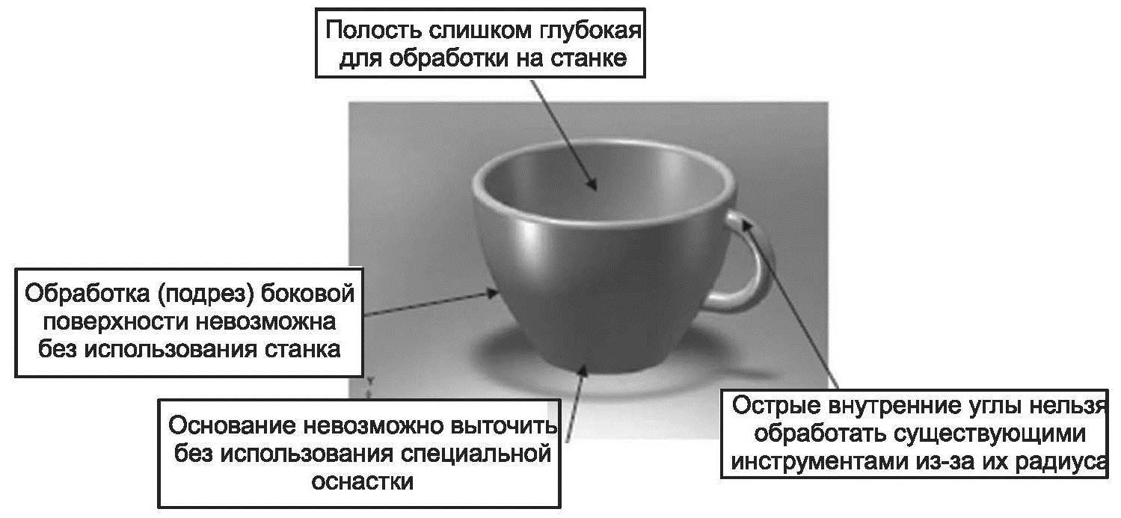
Figure 3.2 – Surfaces whose processing is a problem for CNC machines (text in the figure starting from the top clockwise: the cavity is too deep for processing by the machine, sharp internal corners cannot be processed by existing tools due to their radius, the base cannot be made without using special tools, processing (cutting) of the side surface is impossible without the machine)

Settings
When using CNC machines, it is necessary to determine the sequence of operations in the control program to manufacture a given part, and also to select the tool, adjust the machining speed, position and angle of approach, etc. Many AM devices have a choice of options, but the labor and time required to select a range, processing complexity and consequences in case of incorrect selection are minimal compared to CNC machines. The worst thing that can happen when using an AM device is manufacturing of a low quality part, if the settings are not carefully chosen. Incorrect settings on the CNC machine result in serious damage to the part and may even pose a hazard to personnel.

- Examples of additive manufacturing products

Figure 3.3 shows products manufactured using various AM processes.
The product (a/а) was produced by a machine for stereolithography and is a simplified fuselage for an unmanned aerial vehicle.
Parts (b/б) and (c/в) were made by spraying the material (see Chapter 7). The example of part (b/б) demonstrates the possibility of simultaneous application of several materials, in this case one set of heads is used for applying a transparent material, and the other set is used for applying a dark material. In both products (b/б) and (c/в), there are rotating assemblies that are manufactured using a removable support.
The product (d/г) is made from metal, it is manufactured by a metal powder bed fusion machine using an electron beam as an energy source.
The product (e/д) is manufactured on a sheet-joining machine that has an ink-jet printing of materials of several colors.
Products (f/е) and (g/ж) are manufactured using the material extrusion method. The part (f/е) is a ratchet mechanism, which is manufactured due to the correct design of the joints and the use of the retractable support.
Products (i/з) and (j/и) are made by sintering a polymer powder from a PBF polymer. When manufacturing parts from this material at the points of rotation, the supports are not needed.
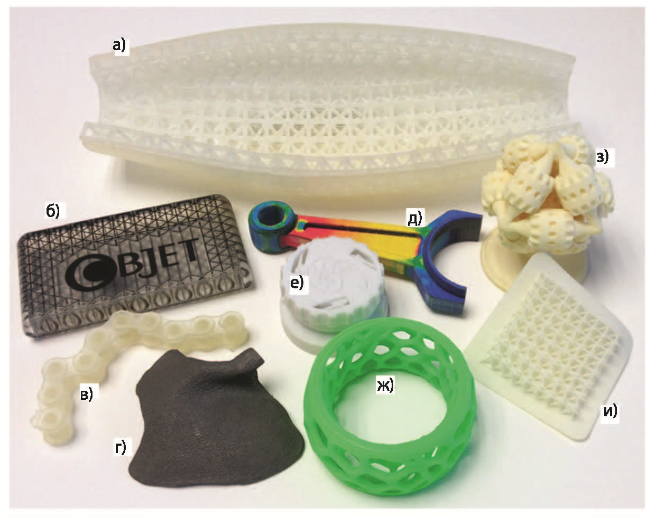
Figure 3.3 – Manufacturing of products using AM technology

- Materials for additive manufacturing
For additive manufacturing, a large number of different materials are used ranging from plastics to metals, the main ones are the following:
ABS plastic filament is created from acrylonitrile butadiene styrene - the same plastic that is used in the production of LEGO parts. The material is known for its ability to resist fracture during impacts and drops.
PLA plastic filament is created from polylactic acid. It is produced from renewable resources (corn cobs, tapioca roots or from sugar cane).
Polyvinyl alcohol (PVA) is a material with unique properties and special application. The main feature of PVA is its water solubility.
Polyethylene terephthalate (PET) has a high chemical resistance to acids, alkalis and organic solvents, high mechanical strength and shock resistance in a wide range of temperatures (from -40°C to 75°C). It is resistant to abrasion and multiple deformations during stretching and bending. Hardening is possible.
High impact polystyrene (HIPS) has good impact resistance, moldability, ductility. With 3D printing, polystyrene demonstrates physical properties, very similar to the popular ABS plastic. In this case, it is soluble in limonene. It is resistant to tearing. It has a heat shrinkage due to heat - with 3D printing of large parts delamination with this material is minimal.
Elastan is a highly elastic material that is well suited for 3D printing of elastic products. Products made of this material can be used in many aggressive environments.
Plastan has an amorphous structure and is a transparent material (often with a yellowish or bluish tinge) with a light transmission up to 87%; it has a high plasticity. It is characterized by increased resistance to shock and high heat resistance. Plastan is resistant to weak acids, solutions of alkalis and salts, alcohols, water.
Polycarbonate (PC) has high strength, resistance to high and low temperatures, very high resistance to impact loads, is refractory (it is a heat-resistant self-extinguishing material).
Nylon (Nylon) has a high wear resistance and low coefficient of friction, is intended for printing parts that experience friction.
HDPE or high density polyethylene is a thermoplastic material made from petroleum, hydrocarbon raw materials. It is used for the production of plastic bottles and materials for building structures.
Cement polymers are materials similar in properties to concrete, but which can be applied to a fiber base that makes this polymer more durable than concrete.
The plaster is placed in the building compartment of the 3D printer in the form of a dry powder. Then, the extruder heads wet the powder placed in the mold using the binder fluids layer by layer.
Photopolymers are special compounds that change their properties when exposed to light. They are used in stereolithography.
Wax is usually used for powder forms, stirred and sintered by powerful lasers. It is often used to create forms for the subsequent production of products, like casts of metal jewelry.
Glow in the dark filaments are made from ABS and PLA-plastics of different colors, glowing in the dark with different shades of the base color.
Neon filaments are usually characterized by very bright shades of blue, green, yellow, orange, pink or purple. They are used together with ABS and PLA plastics.
Ceramic powder is a material that is used in a type of 3D printing, called selective laser sintering. The powder here is sintered into an entire shape under the influence of a powerful laser.
Fusible metals and alloys have special impurities that reduce the melting point in comparison with a conventional metal of this type. For example, a metal wire used in soldering is a mixture of tin and lead, which melts easier than each of the constituents alone.
Metallic powders are used in 3D printers equipped with a laser for their sintering.
Graphene is a thin monoatomic carbon layer of graphite. It is not yet used in 3D printing, but American and European researchers are extremely active in finding ways to use this material.
Sand can be melted into glass if there are sufficiently powerful heating sources. Thus, an experimental solar battery was used to manufacture several glass objects.
Chocolate and caramel are grinded and passed through an extruder of a 3D printer just like a plastic filament.
Glaze is an integral element of the production of sugars, obtained by saturating the solution and passing it through the modified extruder head. It is usually used for complex and detailed decoration of confectionery.
The greatest application for FDM printing is ABS and PLA plastics.

Table 3.1 - Comparison of ABS and PLA plastics
Property | ABS | PLA
Mechanical properties | Elastic and less brittle then PLA | PLA is more rigid then ABS
Extrusion temperature, °С | 220-260 | 160-220
Temperature of thermal deformation, °С | 100 | 60
The influence of external temperature factors on the printing process | It is recommended to print using closed printers with additional heating. Platform heating is mandatory | Cooling is necessary during printing, platform heating is desirable
Solvent | acetone | Dichloromethane, limonene
Durability of products | Durable (is made from petroleum products), decomposes under the influence of ultraviolet light | Made from plant materials, decomposes in 2 years (at high humidity and temperature decomposes in 1 month)
Application area | Engineering plastic for creating functional objects | Environmentally friendly material used in medicine, disposable dishes, children's toys and sliding bearings

The quality of the printing depends on the quality of the used filament. The filaments are subject to the following requirements:
"Purity" of the material - the presence of impurities significantly reduces the quality of the product and clogs the extruder;
the rod diameter consistency - the tolerance of the filament diameter of normal accuracy is ± 0,05 mm. The inconsistency of the diameter leads to two significant problems in the interruption of extrusion (the feeder has lost its contact with the filament due to the small diameter or the motor lacks power to feed the filament due to the large diameter) and unstable extrusion (the software controls the extrusion volume by changing the feed rate of the filament, but because of the fluctuation of the filament diameter, the expected volume of the melt does not coincide with the actual volume);
roundness of the filament cross section. If the filament suddenly loses its perfectly round shape and becomes oval, it may cause the extruder to malfunction similar to a case when the filament diameter varies.
In addition to the acquisition of high-quality filament, it is also necessary to pay attention to its storage. ABS and PLA plastics are extremely hygroscopic, the presence of moisture leads to embrittlement, increase in diameter, vaporization during extrusion. The filament should be stored in a sealed package together with the desiccant. Shelf life: up to 12 months.

Additional information:
http://orgprint.com/novosti/idtechex-tendencii-razvitija-rynka-rashodnyh-materialov-dlja-3d-pechati
http://stepconsulting.ru/advices/materialy-dlya-3d-printerov-chto-segodnya-ispolzuyut-dlya-3d-pechati

- Diagram of additive manufacturing processes
AM includes a number of steps for the transition from a virtual model to a finished product. The number of steps depends on the particular product. For the manufacture of small, relatively simple products, only modeling and manufacturing are carried out, and for complex ones, there are many steps.
The general diagram of AM can be represented in the following sequence:
Step 1: Development of the model. A virtual model is created using special software that fully describes the geometric shape and dimensions of the product, or with the help of scanners.
Step 2: Creation of the STL file. The model constructed at the first step is stored in a STL (Stereo Lithography) file that is read by almost all AM devices. The file contains a superficial representation of the 3D model and is the basis for the formation of layers.
Step 3: Slicing. The STL file with the product description is sent to the device. Here some settings are made: the correction of the size, location and orientation of the digital model on the desktop. At this step, with the help of a slicer (programs for transforming a 3D model), the model is "cut" into thin horizontal layers and converted into a digital code (G-code) that a 3D printer can understand.
Step 4: Configuring the device. Before the device is started, AM should be correctly configured. Settings are needed for manufacturing parameters, for example, borders, layer thickness, etc.
Step 5: Manufacturing. This is mostly an automated process, so the device is able to perform it almost without operator control. In some cases, only superficial monitoring of the device operation is necessary, so that no malfunctions occur such as, for example, running out of the printing material, the power supply or software failure, etc.
Step 6: Removing the product. After the completion of the work, you need to remove the product. To do this, sometimes it is necessary to carry out certain actions with the device: wait for the temperature to drop, moving parts to stop, etc.
Step 7: Processing the product. After the product has been removed, it may be necessary to finish it with a tool (remove auxiliary elements, etc.), priming, painting or cleaning before use.
Step 8: Assembling. Individual parts are assembled into the final product according to the diagrams and the drawings.
Many AM devices require careful servicing of both built-in mechanisms and equipment as a whole. In addition, the materials used in some AM processes have a limited shelf life, or require storage under certain conditions that exclude the effects of moisture and light.

- Applications of AM
Architecture. AM is used for making architectural models of buildings, structures, microdistricts, housing complexes with all infrastructure (roads, trees, street lighting). As a material, gypsum composite is used, which ensures a low cost of finished models.
Building. In some countries, when building walls of low-rise buildings, 3D printers for construction are used.
Small-scale production. AM is used for the manufacture of exclusive products, for example, art objects, prototypes and conceptual models of future consumer goods or their structural parts. Such models are used both for experimental purposes and for presentations of new products. The development of metal printing technologies allows the use of additive manufacturing technologies for the production of full-featured parts, including ones for the aviation industry.
Functional testing. AM is used for manufacturing prototypes of products and complex technical devices. For example, to test new mechanisms in an assembly, it is cheaper, faster and easier to make individual components using 3D printing devices.
Health care. 3D-printing devices are used to make devices for prosthetics and dentistry, to make accurate replicas of the human skeleton in order to develop techniques that guarantee a successful surgery (Figure 3.4).

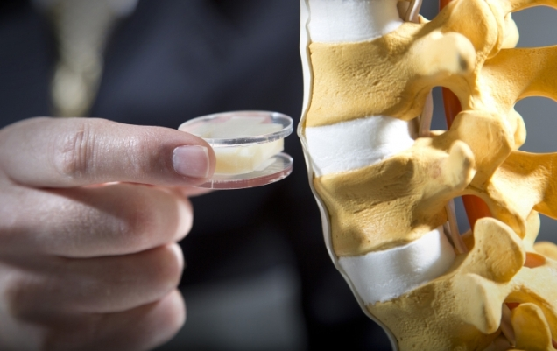 | 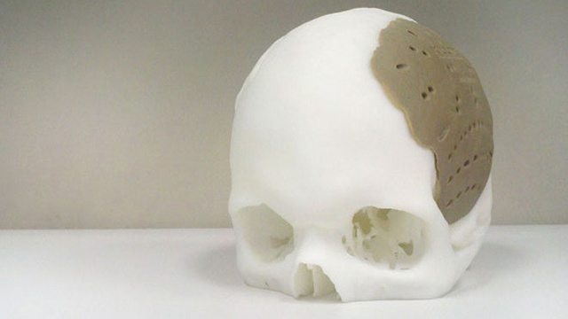
Figure 3.4 – Examples of using 3D-printing in health care

Education. Equipping educational institutions teaching engineering and design with 3D printing devices increases the visibility and effectiveness of the educational process.
Manufacture of clothing and footwear. AM devices allow to make individual items from dissimilar materials with different properties and individual ergonomic characteristics (for example, the size and shape of the foot for shoes).
Jewelry. AM is used to create wax prototypes for jewelry items.
Printing of toys and souvenirs. 3D printing devices are used to create full-color prototypes before the product is launched into mass production. Souvenirs are printed from gypsum materials that are processed additionally to increase the strength of the finished product.

Additional information:
https://3dsmart.com.ua/blog/sfery-primeneniya-3d-pechati
http://3dtoday.ru/blogs/54e18bfe8e/what-you-print-examples-of-the-use-of-3d-printing-in-medicine/
http://terem.ru/catalog/3D-PRINT/3D-Technologies-Applications/
https://geektimes.ru/company/top3dshop/blog/280098/

- Advantages of additive manufacturing
Improved properties of finished products. Thanks to the layered construction, the products have a unique set of properties. For example, the mechanical properties, density, residual stress and other properties of parts created by a metal 3D printer are superior to those created by casting or machining.
Saving of material. Additive technologies use essentially the amount of material you need to manufacture your product. Whereas with traditional methods of production, the loss of raw materials can be up to 80-85%.
The possibility of manufacturing products with complex geometry. Equipment for additive technology allows you to produce items that cannot be obtained in any other way. For example, in a case when one part is inside another part. Or very complex cooling systems based on mesh designs (this cannot be made either by casting or by stamping).
Mobility of production and acceleration of data exchange. No more drawings, measurements and cumbersome samples. At the heart of additive technologies lies the computer model of the future product, which can be transmitted in a few minutes to the other end of the world - and immediately begin production.
Schematically, the differences in traditional and additive manufacturing can be represented by the following diagram:
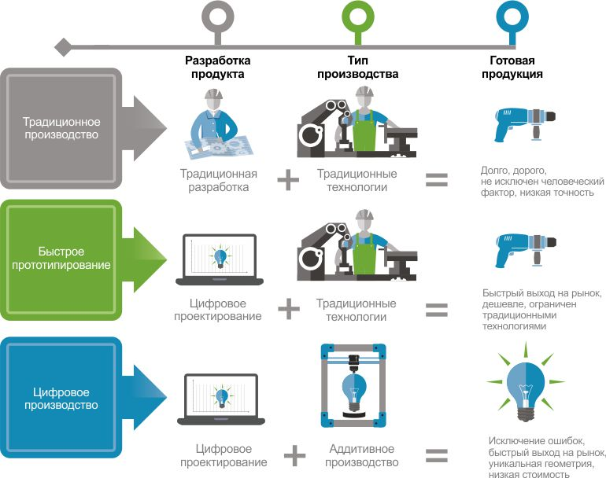
(text in the figure top-to-bottom and left-to-right: product development, manufacturing type, final product; traditional manufacturing => traditional development + traditional technologies = long time, expensive, human factor, low precision; rapid prototyping => digital design + traditional technologies = short time to market, less expensive, limited by traditional technologies; digital manufacturing => digital design + additive manufacturing = no errors, short time to market, unique geometry, low cost)

- Components of 3D printers using FDM technology
The most accessible and technologically simple method of printing is fused deposition modeling (FDM). It is based on the sequential layering of a thin thread of molten plastic up to the creation of a solid three-dimensional object. The consumable material is a plastic filament wound around the reel. Occasionally, individual plastic rods are used. The standard filament diameter is 1.75 mm or 3 mm.
FDM 3D printer (Figure 3.5) consists of the following main structural components:
- a frame;
- the extruder with heater, fan and temperature sensor;
- working table;
- several motors, pulleys and end sensors at zero point of axes.
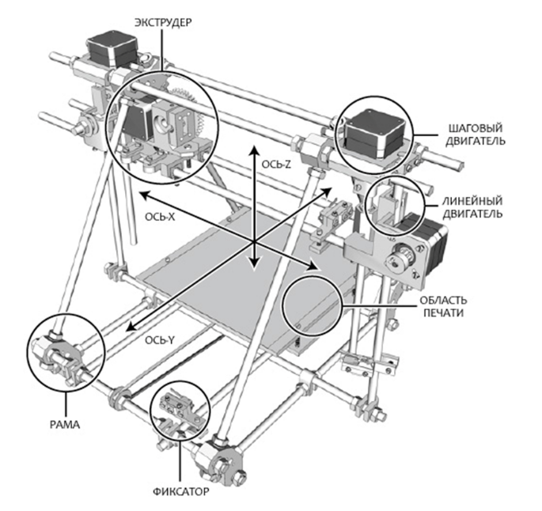
Figure 3.5 – Diagram of FDM 3D-printer (text in the figure starting from the top clockwise: extruder, Z axis, step motor, linear motor, printing area, clamp, frame, Y axis, X axis)

1) The housing material is important if it carries a load. Many FDM printers are available with wooden cases, which helps absorb vibration when printing, and this positively affects the quality of the models produced. On the other hand, a steel or aluminum frame provides durability and shock resistance of the device.
It matters whether the printer is open or closed. A well-ventilated working chamber is useful when printing PLA-plastic, as this material is glassy for a long time. If the printed layers do not have time to solidify and set, it is possible for them to spread out, or the lower layers may deform under the pressure of the upper layers.
On the other hand, many popular materials (for example, ABS plastic and nylon) have a high degree of shrinkage. By "shrinkage" it means a reduction in the volume of material during cooling. In the case of the same ABS plastic, excessively rapid and uneven cooling of the applied layers can lead to their twisting, or deformation and cracking of the model as a whole. In this case, the closed housing allows achieving slow, uniform cooling of the material.
2) One of the most important components is the extruder (Figure 3.6), that is, the print head of the printer.
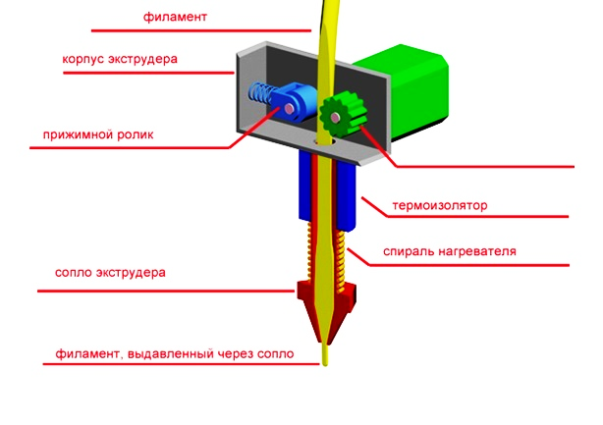
feeder mechanism
Figure 3.6 – Extruder diagram (text in the figure starting from the right clockwise: feeder mechanism, thermo-isolator, heating coil, filament being extruded through the nozzle, extruder nozzle, clamping roller, extruder housing, filament)

Typically, the pull mechanism consists of gears or screws driven by an electric motor. The electric motor drives the gears, supplying the plastic filament to the nozzle. In the nozzle, the filament is melted, followed by the extrusion of a viscous material.
An exceptionally important issue is the sharp temperature gradient between the lower and upper part of the nozzle - for this purpose there is a fan.
When the glass transition temperature threshold is exceeded, the plastic becomes soft, but not yet viscous, expanding in volume. In this state, the friction of the material with the inner walls of the nozzle increases. If the length and the area of this section are too large, the total coefficient of friction may become unbearable for the pulling mechanism. Thus, the length of the section with plastic at the glass transition temperature should be as short as possible.
In this case, the time the plastic spends in the molten state should be minimized, since many thermoplastics lose plasticity after a long stay at high temperatures, and the resulting solid particles can clog the nozzle.
The diameter of the nozzle may vary, but the average value is 0.3 mm. Nozzles of smaller diameter allow achieving higher resolution, while increasing the diameter increases the speed of manufacturing and reduces the risk of jamming the nozzle.
3) The task of the table is to prevent tears or cracks in the model, and also to provide a reliable grip between the first layers of the printed part and the working surface. For this purpose, many printers are equipped with heated platforms. When printing with ABS plastic heating is a must. The table is made of different materials: glass, acrylic, aluminum. Depending on the coordinate system used, the table can be movable or static.
4) Currently, there are two basic methods for positioning the extruder: moving in Cartesian coordinates and the method used by delta printers.
In a printer with a Cartesian coordinate system, each of its parts moves along one or more axes. But since in this design movable parts can be only two: a table and an extruder, the main options most common in commercial printers are the following:
- the table moves along one of the axes, the extruder moves along the other and vertically;
- the table moves only vertically; extruder moves in two axes;
- the extruder moves along one of the axes, the table – along the other and vertically.
Another option that is gaining popularity is the use of a delta-like coordinate system. Such devices in the industry are called "delta robots" (figure 3).
In delta printers, the print head is suspended on three manipulators, each of which moves along a vertical guide.
Synchronous symmetrical movement of manipulators allows you to change the height of the extruder above the platform, and asymmetric movement causes the head to move in the horizontal plane.
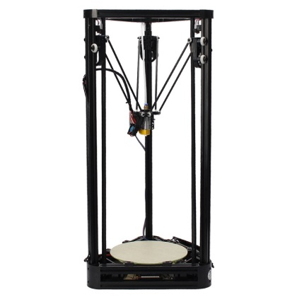
Figure 3.7 – Delta-printer

Some printers are controlled only through a computer (usually via a USB port, but there are models with a Wi-Fi connection), some have their own control panel, with which in the simplest case it is possible to monitor temperatures on the LCD display, start and stop printing, and in more advanced versions also carry out calibration, load and unload plastic filament. There are printers with built-in card reader for SD-cards, through which you can download a file and then print the model without the involvement of a computer.
Along with the already considered stationary 3D printer, there are similar devices that are much inferior to it in size, speed and accuracy of printing - 3D-pens. In essence, a 3D pen is nothing more than a hand-held extruder.

Additional information:
http://3dtoday.ru/wiki/FDM_printers/#.D0.9A.D0.BE.D0.BD.D1.81.D1.82.D1.80.D1.83.D0.BA.D1.82.D0.B8.D0.B2.D0.BD.D1.8B.D0.B5.D1.8D.D0.BB.D0.B5.D0.BC.D0.B5.D0.BD.D1.82.D1.8B2
http://3dtoday.ru/wiki/3D_print_technology/
http://techno-guide.ru/informatsionnye-tekhnologii/3d-tekhnologii/kak-rabotaet-3d-printer-printsip-raboty-trekhmernoj-pechati.html
http://3dpr.ru/printsip-raboty-3d-printera
http://orgprint.com/wiki/3d-pechat/Klassifikacija-3D-printerov-po-osjam-dvizhenija-jekstrudera-i-platformy
http://ixbt.com/printer/3d/3d_fdm.shtml
https://3dnews.ru/peripheral/3d-print/print

- The factors that affect the quality of 3D printing
Slicer. It is important to understand that the quality of the software will directly affect the result of printing. Even if the model is made perfectly, the incorrect generation of G-code will lead to poor quality results. Therefore, it is very important to choose a good version of the slicer. Among the slicers it is important to note the following: Slic3r, Cura, Kisslicer, Makerbotdesktop.
Generated by different slicers g-code can lead to significantly different results when printing (Figure 3.8).
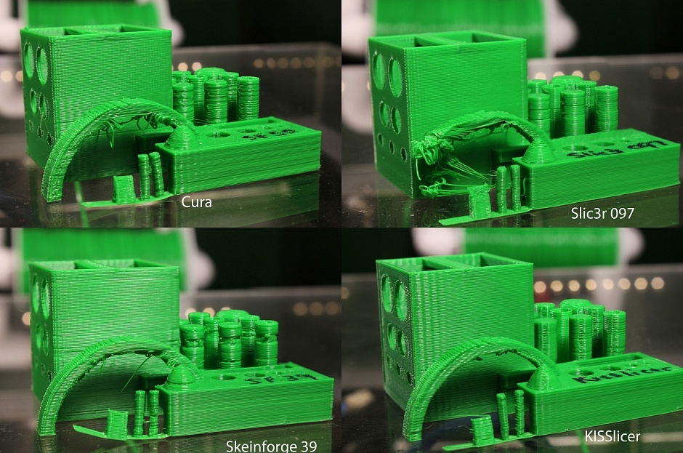

Figure 3.8 – Examples of products made with different slicers

It is not necessary to be guided by this drawing based on the principle “this slicer has obviously made better”, since this will strongly depend on the specific 3D models and versions of the slicers.
In order to transform the model into layers, the slicer must be adjusted, specifying the following basic parameters:
- print quality;
- filling;
- the extruder speed and its temperature;
- support characteristics;
- used material.
Selection of the quality of the surface of the part, thickness of the layer, significantly affects the time required to print the part (Figure 3.9).
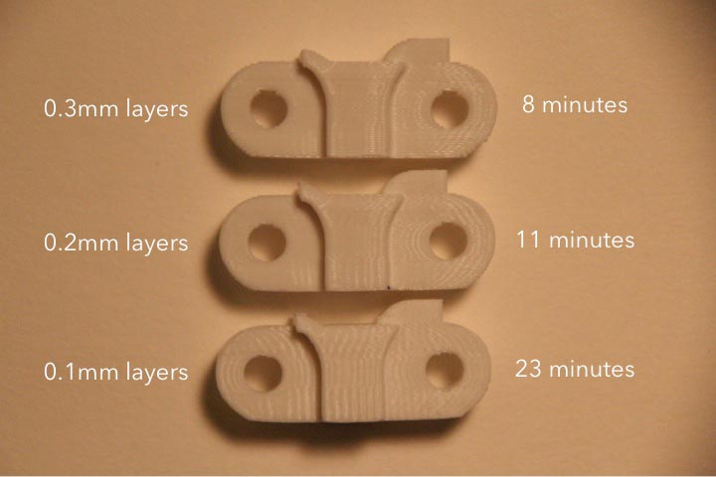
Figure 3.9 – Dependence of the printing time on the thickness of the layer

Filling is described by specifying:
- thickness of the top and bottom of the part. The thickness of the top affects if the percentage of filling of the part is low and the filament sags heavily. There may be lacerated holes and sticking solidified plastic filament.
- infill percentage. The density of the grating inside the part. 0% is a hollow part. It is necessary for strength and support of the upper layers.
Also, infill percentage has no less effect on printing time than the thickness of the layer.

Additional information:
https://3dpt.ru/page/soft
https://habrahabr.ru/post/196182/
https://3deshnik.ru/blogs/akdzg/obzor-osnovnyh-nastroek-slajsera-cura
http://3dtoday.ru/blogs/3dpicasso/cura-your-caring-assistant-in-the-world-of-printing-part-1/
https://3deshnik.ru/blogs/akdzg/sekrety-slajsera-cura-chast-1
https://3deshnik.ru/blogs/akdzg/sekrety-slajsera-cura-chast-2
https://3deshnik.ru/blogs/akdzg/sekrety-slajsera-cura-chast-3
https://3deshnik.ru/blogs/akdzg/cura-optimizatsiya-nastroek-retrakta
http://support.3dverkstan.se/article/30-getting-better-prints

Defects in FDM printing and how to solve them. The FDM printing process is associated with the formation of a number of defects, and this is also typical for expensive printers using high-quality materials.

Table 3.2 – Defects of FDM printing and ways to avoid them

Defect type | Reason | Fixes
No extrusion at start of printing | The extruder was not filled before printing | - “manually” extrude the filament;  - It is necessary to print a preparatory ring (skirt) around the part
 | The nozzle is too close to the table | - increase the vertical clearance (Z axis)
 | The drive gear tears the filament | Manually feed the filament and eliminate the cause of tearing:  -increase the extruder temperature;  -reduce the printing speed;  -clean the nozzle.
The first layer does not stick to the table | Printing table is not levelled | The printing table should be appropriately leveled using Bed Leveling Wizard, it can be found in Tools menu
 | The nozzle starts to work too far from the table | The problem can be solved by configuring G-Code
 | The first layer is printed too fast | Print the first layer at a lower speed. Most slicers have this option. It can be usually found in menu  Edit Process Settings → First Layer Speed.  For example, if you set this parameter to 50%, then the first layer will be printed 50% slower than the rest. If you think that this is not enough, try to change it again.
 | Incorrect temperature or cooling settings | In the corresponding menu, for example, Edit Process Settings → Temperature, it is necessary to choose the necessary platform from the list and specify the temperature of the first layer.
 | The surface of the printing table (tape, glue, other materials) | Many use glue applied on the table or various kinds of sprays. It can be a hairspray, glue-pencil or more clever sticky substances that will solve the problem, if nothing else helps.
 | If nothing helps, use the fields: raft or brim
Insufficient extrusion | Incorrect filament diameter | Correctly set the filament diameter in the printer software
 | The coefficient of extrusion is too low | Increase the coefficient of extrusion  For PLA – 0.9, for ABS – 1.0.
Excessive extrusion | Incorrect filament diameter | Correctly set the filament diameter in the printer software
 | The coefficient of extrusion is too low | Increase the coefficient of extrusion  For PLA – 0.9, for ABS – 1.0.
Slots in the top layer | Insufficient top layers | Increase the quantity of solid layers (min. thickness of solid layers 0.5 mm)
 | Too low infill percentage | Increase infill percentage
 | Insufficient extrusion | See Insufficient extrusion
Hairs or spider web | Small retraction distance | Increase retraction distance
 | Small retraction speed | Increase retraction speed
 | Too high temperature | Reduce extrusion temperature

After the end of FDM printing, the supporting structures are removed. The machining is performed with an abrasive and cutting tool. Chemical treatment is performed to smooth out the printed layers and to impart a glossy surface to the model. In addition to the appearance, this improves the adhesion of the layers due to reflow, but can "eat" small parts, and also puttying and painting.

Additional information:
http://3dtoday.ru/blogs/rec/how-to-print-flexible-materials-in-conventional-fdm-printer-educationa/
https://3dpt.ru/page/faq

