OP3.2.5
FABLAB Project Management

Version 3.0

The training course developed within the project of the European Commission program Erasmus+ «Development of a network infrastructure for youth innovation entrepreneurship support on Fablab platforms» (561536-EPP-1-2015-1-UK-EPPKA2-CBHE-JP)
http://fablab-erasmus.eu/

This document has been prepared with support from the European Commission.
However, it reflects the views only of the authors, and the Commission cannot be held responsible for any use which may be made of the information contained therein.

Document Information
Grant Agreement Number | 561536-EPP-1-2015-1-UK-EPPKA2-CBHE-JP |  |  | Acronym |  | FabLab
Full Title | Development of a network infrastructure for youth innovation entrepreneurship support on Fablab platforms
Topic | ERASMUS+ CBHA
Start Date | 15thOctober 2015 | Duration |  |  | 36 months
Project URL | http://fablab-erasmus.eu/
Project Coordinator | Dr. Dorin Festeu, Buckinghamshire New University, United Kingdom
Deliverable | 5 training courses developed
Work Package | WP3 – Fablab development
Date of Delivery | Contractual |  |  | M3 | Actual |  | 30/09/2018
Nature | R - Report | Dissemination Level |  |  | P - Public
Lead Beneficiary
Responsible Author | BNTU (Р8) |  | Email | vtrepachko@bntu.by
 |  |  | Phone | +375 29 190 95 95
 |  |  | Skype address | vmtrepachko
Responsible Author
Reviewer(s): | All partners
Keywords | Waterfall Methodology, Critical Chain / Path Method, Agile Methodology, Scrum methodology, Kanban, Event Chain Methodology, Extreme Project Management, Lean, Six Sigma, Lean Six Sigma, PRiSM

Document History
Version | Issue Date | Stage | Changes | Contributor
1.0 | 20/09/2017 | Draft | Circulation of the 1st DRAFT version (1st level check) | STP BNTU
2.0 | 05/10/2017 | Draft | Circulation of the 2st DRAFT version (2nd level check) | BUCKS
3.0 | 01/11/2017 | Final | Final version | BNTU

Content
Course Descriptors 5
Learning outcomes 5
Course contents 5
Recommended or required reading 6
Planned learning activities and teaching methods 8
Assessment methods, criteria and regime 9
Skills and Personal Development Plan Statement 9
1. Project management methodologies 10
2. The traditional, sequential methodologies 11
2.1. Waterfall 11
2.2. Critical Chain / Path Method 12
3. The Agile Family 13
3.1. Agile Methodology 13
3.2. Scrum methodology 15
3.3. Kanban 17
4. The Change Management Methodologies 19
4.1. Event Chain Methodology (ECM) 19
4.2. Extreme Project Management (XPM) 20
5. The Process-Based Methodologies 21
5.1. Lean 21
5.2. Six Sigma 22
5.3. Lean Six Sigma 23
6. Other Methodologies 23
6.1. PRiSM 23
6.2. Benefits Realization 24

Course Descriptors
Course title: | FABLAB Project Management
Course unit code | FabMan
University delivering the course: | KhNUE, IASA-KPI, TNTU, BSU, BNTU
Type of course unit | Optional
Level of course unit | Masters level
Number of ECTS credits allocated | 3 Credits (75-90 hours of student work)
Mode of delivery | lectures, seminars, business games, independent work, distance learning…
Prerequisites and co-requisites: | Students enrolled in this course would have ideally passed an Engineering and IT programme

Learning outcomes
On successful completion of the module, students will be able to:
-Critically evaluate approaches to the problem solution from the problem definition, through selection of a solution method up to the evaluation of the final product.
-Employ co-operative and synergistic approaches to team work, problem solving and opportunity development.
-Employ critical judgment, select tools, methodologies, key theories and critical discourses that are appropriate to particular innovative ideas.
-Utilize creative risk taking and experimentation, learn from failure and understand the implications of the actions.

Course contents
1. Project management methodologies
2. The traditional, sequential methodologies
3. The Agile Family
4. The Change Management Methodologies
5. The Process-Based Methodologies
6. Other Methodologies

Recommended or required reading
Main:
- Crawford C M & di Benedetto C A (2008), New Products Management, 9e McGraw-Hill.
- Barczak G, Griffin A & Kahn K (2009), Trends and Drivers of Success in NPD, Journal
of Product Innovation Management, 26, 3-23.
- Cooper, Robert G. (2008), The Stage-Gate Idea-to-Launch Process, Journal of Product
Innovation Management, 25, 213-232.
- Beerens, Joris et al. (2005) Mastering the Innovation Challenge, Booz Allen Hamilton.
- Cooper R G (1999), The Invisible Success Factors in Product Development, Journal of
Product Innovation Management, 16, 115-133.
- Cooper R G, Edgett S J & Kleinschmidt E J (1999), Portfolio Management for New
Product Development, R&D Management, 16, 333-351.

Additional:
- Davis J et al. (2001), Determining a Projects Probability of Success, Research- Technology Management, May-Jun, 51-57.
- Dolan R J (1992), Concept Testing, Chap 2 in Managing the New Product Development
Process,
- Dolan ed, Addison Wesley. *Langerak, Fred; Hultink, Erik Jan; Robben, Henry S.J.
(2004) The Impact of Market Orientation, Product Advantage, and Launch Proficiency on
- New Product Performance and Organizational Performance.
Journal of Product Innovation Management, Vol. 21 Issue 2, p79-94.

Internet based materials:
  - http://europeanmakerweek.eu/
  - http://fabhub.net/showthread.php?31-quot-Getting-Started-quot-projects-20-1-hour-projects-at-the-Fab-Lab
  - https://engineeringclicks.com/forum/threads/fablab-in-cambridge.493/
  - http://unctad.org/
  - http://fablabsuk.co.uk/
  - https://slideshare.net/Pietel/the-role-of-design-thinking
  - https://slideshare.net/zaana/introducing-design-thinking
  - https://slideshare.net/golnarzamani5/design-thinking-powerpoint
  - https://slideshare.net/oeconsulting/design-thinking-by-operational-excellence-consulting
  - http://creativityatwork.com/design-thinking-strategy-for-innovation/
  - https://interaction-design.org/literature/article/5-stages-in-the-design-thinking-process
  - https://designthinking.ideo.com/
  - https://dschool.stanford.edu/resources/virtual-crash-course-video
  - https://slideshare.net/navin_sosimple/process-design-15773913
  - https://linkedin.com/learning/executive-leadership/influence-without-authority
  - https://hbr.org/2016/09/the-difference-between-good-leaders-and-great-ones?referral=03759&cm_vc=rr_item_page.bottom
  - https://slideshare.net/sandeepchhaya/how-to-overcome-fear-of-failure
  - https://pickthebrain.com/blog/overcome-fear-of-failure/
  - http://wikihow.com/Overcome-Fear-of-Failure
  - https://slideshare.net/quillshare/quality-function-deployment-qfd-seminar-presentation
  - https://slideshare.net/mmarleanne/quality-function-deployment-45707746
  - https://slideshare.net/Juneeramos/2014-jra-mmp1-dayupdatedppt?qid=3be3c3ea-2b5c-4ab5-aba5-71a345c59c86&v=&b=&from_search=3
  - https://slideshare.net/mkeppell/2013-nov-pdpteamculture-copy?qid=3be3c3ea-2b5c-4ab5-aba5-71a345c59c86&v=&b=&from_search=5
  - https://slideshare.net/tulasikrishnaravi/flexibilty-addition?qid=3be3c3ea-2b5c-4ab5-aba5-71a345c59c86&v=&b=&from_search=6
  - https://slideshare.net/hayordeyji/goal-setting-and-managing-priorities-by-samuel-akinlotan?qid=3be3c3ea-2b5c-4ab5-aba5-71a345c59c86&v=&b=&from_search=9
  - https://youtube.com/watch?v=rq0HG6sWc8s
  - https://youtube.com/watch?v=TR5r4HY1pn4
  - https://youtube.com/watch?v=OQpsTz4xt4I
  - https://youtube.com/watch?v=ZqZrgaNlnu0
  - https://youtube.com/watch?v=tJs3n-5csCg
  - https://slideshare.net/GrapeMedia/random-140227064224phpapp02?qid=d4f78446-d804-4319-a810-c03dbd47179f&v=&b=&from_search=8
  - https://slideshare.net/sobolevsp/practical-experience-from-critical-chain-project-management-ccpm?qid=d4f78446-d804-4319-a810-c03dbd47179f&v=&b=&from_search=6
  - https://slideshare.net/parepa/ccpm-vebinar-21-01-2010?qid=d4f78446-d804-4319-a810-c03dbd47179f&v=&b=&from_search=1
  - https://youtube.com/watch?v=5A5XCuWMG4o
  - https://youtube.com/watch?v=lYR3KNTE9SU
  - https://habrahabr.ru/post/142023/
  - http://leadinganswers.typepad.com/leading_answers/files/original_waterfall_paper_winston_royce.pdf
  - http://pravo.studio/innovatsionnyiy-menedjment-book/kaskadnaya-spiralnaya-modeli-upravleniya.html
  - https://habrahabr.ru/post/226323/
  - https://youtube.com/watch?v=mkVQ6YM1ltg
  - https://corpedgroup.com/program-areas/project-management/pm-virtual-instructor-led.asp
  - https://youtube.com/playlist?list=PLhDoHe0AQ_kFlr_lv4r_BXObdoGXYPutF

  - Design Thinking
https://slideshare.net/Pietel/the-role-of-design-thinking
https://slideshare.net/zaana/introducing-design-thinking
https://slideshare.net/golnarzamani5/design-thinking-powerpoint
https://slideshare.net/oeconsulting/design-thinking-by-operational-excellence-consulting
http://creativityatwork.com/design-thinking-strategy-for-innovation/
https://interaction-design.org/literature/article/5-stages-in-the-design-thinking-process
https://designthinking.ideo.com/
https://dschool.stanford.edu/resources/virtual-crash-course-video

  - Detailed Design Plans
https://slideshare.net/navin_sosimple/process-design-15773913

  - Influence without Authority
https://linkedin.com/learning/executive-leadership/influence-without-authority
https://hbr.org/2016/09/the-difference-between-good-leaders-and-great-ones?referral=03759&cm_vc=rr_item_page.bottom

  - How to Overcome Fear of Failure
https://slideshare.net/sandeepchhaya/how-to-overcome-fear-of-failure
https://pickthebrain.com/blog/overcome-fear-of-failure/
http://wikihow.com/Overcome-Fear-of-Failure

  - Quality Function Deployment
https://slideshare.net/quillshare/quality-function-deployment-qfd-seminar-presentation
https://slideshare.net/mmarleanne/quality-function-deployment-45707746

  - Managing Multiple Priorities
https://slideshare.net/Juneeramos/2014-jra-mmp1-dayupdatedppt?qid=3be3c3ea-2b5c-4ab5-aba5-71a345c59c86&v=&b=&from_search=3
https://slideshare.net/mkeppell/2013-nov-pdpteamculture-copy?qid=3be3c3ea-2b5c-4ab5-aba5-71a345c59c86&v=&b=&from_search=5
https://slideshare.net/tulasikrishnaravi/flexibilty-addition?qid=3be3c3ea-2b5c-4ab5-aba5-71a345c59c86&v=&b=&from_search=6
https://slideshare.net/hayordeyji/goal-setting-and-managing-priorities-by-samuel-akinlotan?qid=3be3c3ea-2b5c-4ab5-aba5-71a345c59c86&v=&b=&from_search=9

Planned learning activities and teaching methods
The primary means of learning for student is through practice. This is supported and developed through:
1. Project briefings.
2. Set and self-initiated project briefs.
3. Peer learning.
4. Self and peer assessment.
5. Guest speakers.
6. Group discussions, reviews and critiques;
7. Working on live projects;
8. Mentoring;
9. Independent study.

For flexible and distributed learning
Web-based sessions lead by instructor provide methodological and conceptual framework for students’ learning. All the slides and materials from the class will be available electronically.
Web-based seminars will be used to strengthen the knowledge of newly learned methods and concepts, and to explore their application to particular complex business cases.
Students are encouraged to ask questions and discuss the material in “live” mode online. There will be a web-based message board for the course. Students are welcome to post questions on this board and these discussions will be monitored and facilitated by the lecturer. The main accent will be made on independent learning.

Assessment methods, criteria and regime
Progress and learning is assessed not only at the end but throughout the entire course. Evidence of an ability to think through and critically analyse challenges will be highly rewarded in the assessment.
Students' grades will be determined by individual Assignments, based on description of the key idea, normative regulation and steps necessary to build innovation pipeline and supply it with ground-breaking ideas.
The relative weight of Assignment Brief will be set at 100%.
It will be marked on the basis of:
The aim of the report clearly formulated 20%;
Coherence of the arguments and reflection 10%;
Reflection based entirely on the description of facts and events 40%;
Utilization of adequate terminology to describe the project management 20%;
Evidence of activities undertaken.

Skills and Personal Development Plan Statement
FABLAB Project Management module provides the opportunity for students to:
1. Obtain fundamental knowledge of the phenomenon of innovation and innovation processes from the perspective of firms and industries
2. Appreciate the importance of understanding innovation-related issues for the development of businesses and industries.
3. Expand the Innovation perspective to include design as integral to the innovation process and as a practical approach to product/service development;
4. Effectively participate in and manage new product projects
5. Research & analyse key innovation literature and then apply learning
6. Contribute as an individual to team performance through participation in team- based
market analysis and problem solving
7. Apply tools and techniques for the effective development of new products
8. Improve communication and presentation skills
9. Debate, formulate and solve problems connected with new product development
10. Develop new product proposals and prepare a business case for new product development project Values and attitudes
Be aware of what new product development means to business and why it has become
important Be aware of the challenges and opportunities posed by new product development
Be aware of the importance of the inter-relationship between marketing and other
business functions for new product development success

- Project management methodologies

Over the course of a project, you'll make hundreds of decisions. And one of the first decisions you'll make is choosing which project management methodology to follow.

“You mean there’s more than one project management methodology?” There are quite a lot of them actually, and some even combine to form new hybrid approaches. But what are they exactly? How do they help project teams work better? And what makes one methodology better than another?

Let's take a look at some of the major project management methodologies:

1. The Traditional, Sequential Methodologies
- Waterfall
- Critical Path Method (CPM)/ Critical Chain Project Management (CCPM)
2. The Agile Family
- Agile
- Scrum
- Kanban
3. The Change Management Methodologies
- Event Chain Methodology (ECM)
- Extreme Project Management (XPM)
4. The Process-based Methodologies
- Lean
- Six Sigma
- Lean Six Sigma
5. The Other Methodologies
- PRiSM
- Benefits Realization

In this chapter we will take a look at some of the top project management methodologies grouped together by similarity and popularity.

- The traditional, sequential methodologies

  - Waterfall
Waterfall was one of the first project management methodologies to come into being. It offered a difference from more “traditional” approach to projects, where everything was worked on in sequence and each stage of the sequence was defined as the project went ahead.

In contrast, Waterfall aims to eliminate risk by outlining all the steps of the project from the beginning. The crux of the methodology is that if you spend more time in the beginning of a project outlining the design and requirements, then the actual project will flow fast and smooth, like a waterfall. Each project phase is 100% completed before moving on to the next.

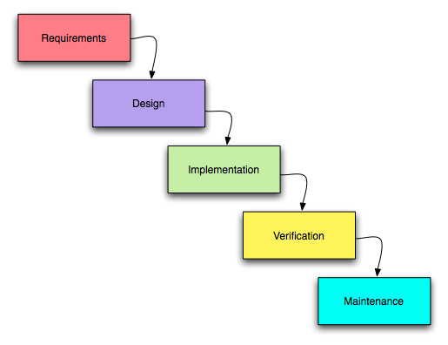
Figure 2.1 - Scheme of the Waterfall methodology

Advantages of Waterfall
Is your project mission-critical? Is it highly complex? Do you need an exceptionally high level of fault tolerance? Waterfall is for you.

Disadvantages of Waterfall
Waterfall can be quite a rigid system, and can lack the flexibility to deal with faced-paced and changeable projects.

  - Critical Chain / Path Method
While Waterfall and Agile focus more on schedules and tasks, Critical Chain / Path aims to solve resource issues and is designed for teams where people have flexible skillsets with a lot of crossover. Each project begins by setting out a chain of core elements (the critical chain / path) necessary to complete the project, and then estimate milestones and completion dates based on those elements.

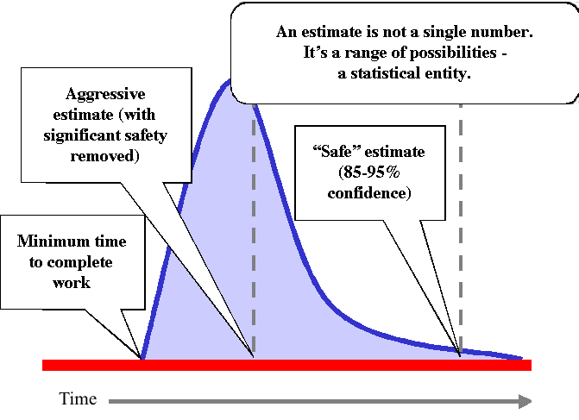
Figure 2.2 - End time of the problem as a probability distribution

Advantages of Critical Chain / Path Method
With resources mapped out, you know exactly who is available for what part of the project, and collaboration on tasks is made easier.

Disadvantages of Critical Chain / Path Method
Because additional time buffers are built into each stage of the plan, Critical Path doesn’t work very well for small-scale projects with a quick-turnaround.

- The Agile Family

Today Agile is the most popular project management methodology. Let’s take a look at some of them.
  - Agile Methodology

What Is Agile?
Agile development is based on an incremental, iterative approach. Instead of in-depth planning at the beginning of the project, Agile methodologies are open to changing requirements over time and encourages constant feedback from the end users. Cross-functional teams work on iterations of a product over a period of time, and this work is organized into a backlog that is prioritized based on business or customer value. The goal of each iteration is to produce a working product.

In Agile methodologies, leadership encourages teamwork, accountability, and face-to-face communication. Business stakeholders and developers must work together to align the product with customer needs and company goals.

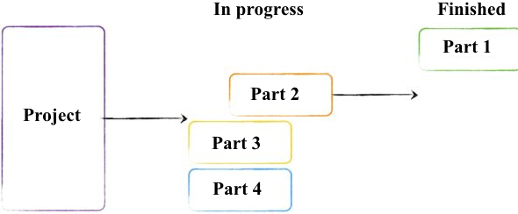
Figure 3.1 - Scheme of Agile Methodology

Advantages of Agile
Agile is a response to some project managers’ dislike of the rigid, linear Waterfall methodology. It focuses on flexibility, continuous improvement, and speed.

Here are some of the top advantages of Agile:
Change is embraced
End-goal can be unknown
Faster, high-quality delivery
Strong team interaction
Customers are heard
Continuous improvement

Disadvantages of Agile
While the level of flexibility in Agile is usually a positive, it also comes with some trade-offs. It can be hard to establish a solid delivery date, documentation can be neglected, or the final product can be very different than originally intended.

The Agile Development Cycle
Here are the phases in the Agile development cycle. It’s important to note that these phases shouldn’t happen in succession; they are flexible and always evolving. Many of these phases happen in parallel.

Planning
Requirements analysis
Design
Implementation, development
Testing
Deployment

How to Estimate Budgets in Agile
Without in-depth, upfront planning, many project managers are unsure of how to calculate the cost and budget of an Agile project.
Estimating the cost before the project even starts can always be challenging, regardless of which project methodology you use. However, in an Agile project, you can tie the amount of time the project will take with its total cost.
First, create a burndown chart and use the burndown rate to estimate how many sprints will be in your project and when the project will end. Then, calculate how much the team will cost based on their hourly rates. Multiply each person’s rate by the number of working hours per week, then multiply that by the number of weeks in a sprint. Once you estimate the initial budget for your team, you can add any other costs, like technology, travel, or equipment.
You could also break down each user story into tasks. Once you have an idea of how many hours it will take to complete each task, you can estimate the project budget.

And lastly, you could use planning poker to estimate the effort required for development goals. Planning poker is a consensus-based, gamified technique for estimating the effort of development goals. Each team member makes estimates by playing numbered cards face-down on the table, instead of saying it out loud. The cards are then revealed and the estimates discussed with the whole team.

How to Get Started with Agile
A simple way to get started with Agile is to incorporate daily stand-up meetings into your project. Daily stand-up meetings are easy to incorporate into any other project methodology you may already be using (even Waterfall) and don’t require any training or knowledge transfer. Meet at the same spot every day for about ten minutes and have everyone talk about what they worked on the day before, what they’ll work on today, and any roadblocks.
If you want to make the complete switch to Agile all at once, you may want to start with understanding why the team and organization want to make this change. What is and isn’t working? What are they looking to improve? Then, you could conduct an Agile assessment, getting a complete view of the people, skills, and technologies used.
Whichever route you choose, remember that Agile is flexible in its very nature. There is no wrong or right way to get started with Agile. Do what works for you and your team.

  - Scrum methodology

What Is Scrum?
Scrum is a subset of Agile and one of the most popular process frameworks for implementing Agile. It is an iterative development model used to manage complex software and product development. Fixed-length iterations, called sprints lasting one to two weeks long, allow the team to ship software on a regular cadence. At the end of each sprint, stakeholders and team members meet to plan next steps.

Scrum follows a set of roles, responsibilities, and meetings that never change. For example, Scrum calls for four ceremonies that provide structure to each sprint: sprint planning, daily stand-up, sprint demo, and sprint retrospective. During each sprint, the team will use visual artifacts like task boards or burndown charts to show progress and receive incremental feedback.

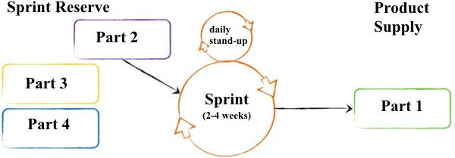
Figure 3.2 - Scheme of Scrum methodology

Advantages of Scrum
Scrum is a highly prescriptive framework with specific roles and ceremonies. While it can be a lot to learn, these rules have a lot of advantages.

The benefits of Scrum include:
More transparency and project visibility
Increased team accountability
Easy to accommodate changes
Increased cost savings

Disadvantages of Scrum
While Scrum offers some concrete benefits, it also has some downsides. Scrum requires a high level of experience and commitment from the team and projects can be at risk of scope creep.

Here are the disadvantages of Scrum:
Risk of scope creep
Team requires experience and commitment
The wrong Scrum Master can ruin everything
Poorly defined tasks can lead to inaccuracies

Roles in Scrum
There are three specific roles in Scrum. They are:
Product Owner
Scrum Master
Scrum Team

Steps in the Scrum Process
There are a specific, unchanging set of steps in the Scrum flow. They include:

Product backlog
Sprint planning
Backlog refinement/grooming
Daily Scrum meetings
Sprint review meeting
Sprint retrospective meeting

Tools and Artifacts in Scrum
In addition to roles and ceremonies, Scrum projects also include certain tools and artifacts. For example, the team uses a Scrum board to visualize the backlog or a burndown chart to show outstanding work. The most common artifacts are:
Scrum board
User stories
Burndown chart
Large-Scale Scrum (LeSS)
Timeboxing
Icebox

How to Get Started with Scrum
Working with Scrum often means changing the team’s habits. They need to take more responsibility, increase the quality of the code, and boost speed of delivery. This level of commitment acts as a change agent; as the teams commit to sprint goals, they are more and more motivated to get better and faster to deliver a quality product.
A good place to start with Scrum is to talk about the roles. Every project must have a Scrum Master, Product Owner, and Scrum Team. You may want to talk about who should be the Scrum Master and Product Owner, or if these roles are already assigned, you may want to clarify their roles and responsibilities.

  - Kanban

What Is Kanban?
Kanban is Japanese for “visual sign” or “card.” It is a visual framework used to implement Agile that shows what to produce, when to produce it, and how much to produce. It encourages small, incremental changes to your current system and does not require a certain set up or procedure (meaning, you could overlay Kanban on top of other existing workflows).

About the Kanban Board
A Kanban board is a tool to implement the Kanban method for projects. Traditionally, this tool has been a physical board, with magnets, plastic chips, or sticky notes on a whiteboard to represent work items. However, in recent years, more and more project management software tools have created online Kanban boards.

A Kanban board, whether it is physical or online, is made up of different swim lanes or columns. The board has three columns: to do, in progress, and done.

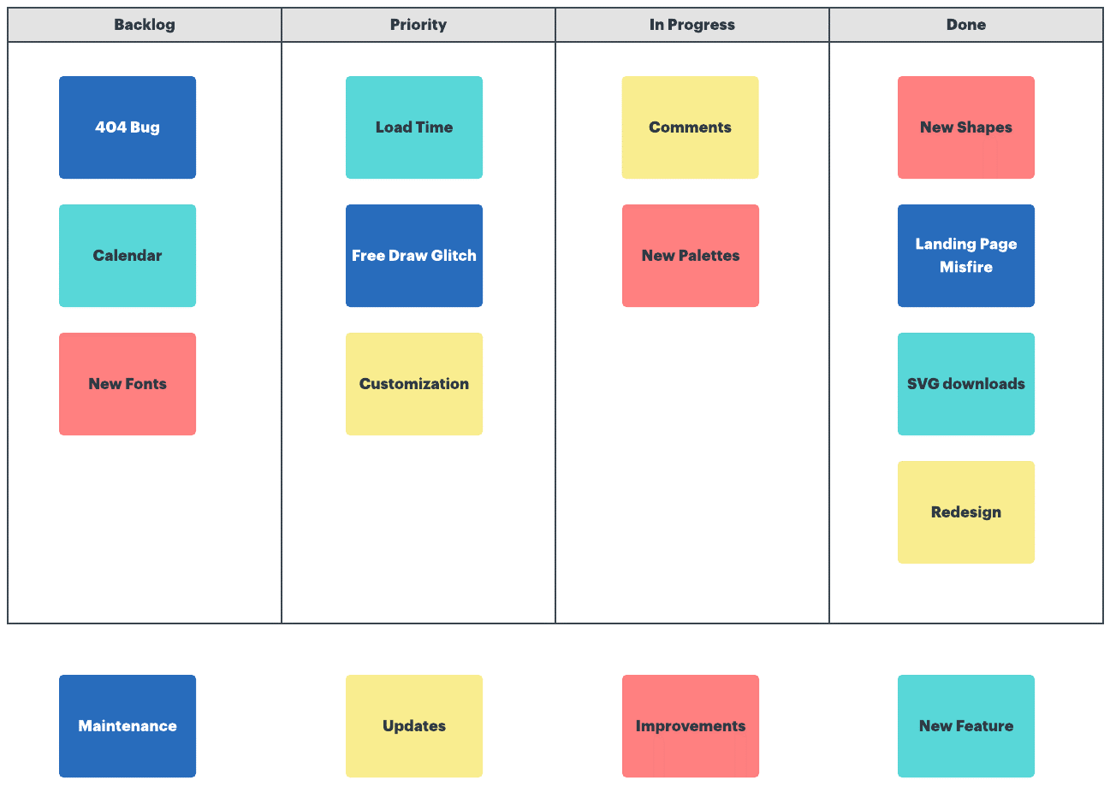
Figure 3.3 - Scheme of the Kanban methodology

Kanban cards (like sticky notes) represent the work and each card is placed on the board in the lane that represents the status of that work. These cards communicate status at a glance. You could also use different color cards to represent different details. For example, green cards could represent a feature and orange cards could represent a task.

Advantages of Kanban
Kanban’s visual nature offers a unique advantage when implementing Agile. The Kanban board is easy to learn and understand, it improves flow of work, and minimizes cycle time.

The advantages of Kanban include:
Increases flexibility
Reduces waste
Easy to understand
Improves delivery flow
Minimizes cycle time

Disadvantages of Kanban
Many of the disadvantages associated with Kanban come with misuse or mishandling of the Kanban board. An outdated or overcomplicated board can lead to confusion, inaccuracies, or miscommunication.

Here’s more on the disadvantages of Kanban:
Outdated board can lead to issues
Teams can overcomplicate the board
Lack of timing

Core Practices and Principles of Kanban
Every Kanban project should follow these core principles:
Visualize the workflow
Limit work in progress
Manage and enhance the flow
Make process policies explicit
Continuously improve

- The Change Management Methodologies

  - Event Chain Methodology (ECM)

Event Chain Methodology is an interesting technique, because instead of focusing on tasks, it focuses on planning for potential risks. Many project managers feel pressure by stakeholders to create optimistic targets for timelines, budgets and milestones. But these targets can create tension within the team as everyone fights to meet unrealistic deadlines. And the moment something goes wrong, the whole project is doomed.

Event Chain Methodology acknowledges and recognizes the risks, and plans for what to do in situations when external events impact the project.

Advantages of ECM
Event Chain Methodology enables managers to examine the relationship between tasks and external pressures. This creates more realistic projects.

Disadvantages of ECM
Sometimes, project managers can get caught up in identifying threats, they can forget that external events can actually be beneficial and present opportunities.

  - Extreme Project Management (XPM)

What is Extreme Project Management?
Extreme project management (XPM) is short and flexible where traditional project management is not. Traditional project management means creating a plan and sticking to it, usually for long-term projects. XPM allows you to alter your project plan, your budget, and your outcome to fit changing needs, no matter what stage the project is in, and usually involves projects that last only a few weeks or even just days.

XPM is meant to help you manage the unknown — those variables that change and pop up as a project progresses. At the end of your project, it‘s about delivering the desired result, not simply the originally planned result. Those people who realize halfway through a project that the original product isn’t ideal have the leeway to modify the plan. Teams using XPM must be willing to attempt to get it right, instead of simply focusing on completing everything after the first attempt.

Advantages of XPM
In XPM, you can alter the project plan, budget, and even the final deliverable to fit changing needs, no matter where the project is. It’s the perfect way to manage projects that have a short timeline of anywhere from a few weeks to mere days.

Disadvantages of XPM
Extreme project management is meant to be fast and nimble. Start by gathering a team of people around you who are willing and ready to embrace this method. If your team members prefer slow-paced work and getting every decision approved by upper management, it won’t work.

How to Get Started with XPM
Create a project plan with extreme project management in mind. That means expecting change, acknowledging that timelines may change, and leaving room for error.
To ensure success, make sure your plan answers all of these questions:
—Who needs what, and why?
—What will it take to do it?
—Can we get what it takes to finish?
—Is it worth it?
Schedule work in short cycles — a few weeks at max.
Have a project kick-off meeting to give everyone the full rundown of the work involved, and get people excited to get to work on a great, new project. Answer every question, and communicate expectations clearly. Make project visibility a priority starting from day 1.
Communicate with your client frequently, listen closely to their wants and needs, and relay their feedback to your team immediately.
Follow up work cycles with check-ins, review sessions, and re-alignment meetings if the project seems to be getting off-track.
When projects or cycles finish, celebrate every win. Make teams feel appreciated to keep them excited about the demanding work. Consider starting every meeting with listing team accomplishments since the last meeting, or going around to have everyone list one accomplishment they’re proud of.

- The Process-Based Methodologies

Then there are the project management methods which practically veer into the areas of business process management wherein each method focuses on work as a collection of processes. While some project managers may argue that these methods belong on some other list, we argue that these are still quite valid ways to plan for and execute a project plan.

  - Lean

What Is Lean?
Lean project management is all about empowering the team to produce awesome results and delivering a ton of value while producing little project waste. Project managers who are dealing with tight budgets and other constraints use Lean to drive self-accountability in the team. There’s an emphasis on processes that help to streamline workflow, such as standardisation and work breakdown structure.

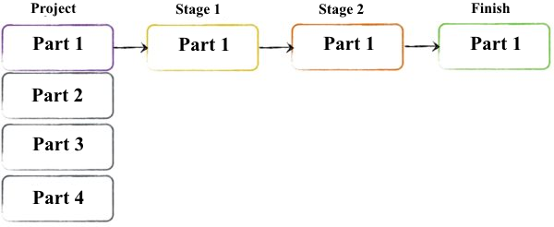
Figure 4.1 - Scheme of the Lean methodology

Advantages of Lean
When budgets are low, resources are scarce, and deadlines are short, Lean can help you make the cuts you need while still deliver quality work.

Disadvantages of Lean
Lean relies on decisions being made quickly and decisively - and dilly-dallying will corrupt the process

How to Get Started with Lean
Here are five principles of lean thinking, that can have a big impact on projects:
Identify Customers and Specify Value
Identify and Map the Value Stream
Create Flow by Eliminating Waste
Respond to Customer Pull
Pursue Perfection

First, you need to think in terms of usable customer value, not long lists of features functions and requirements.
Second, you can use the concept of the value-stream to both critique the development life-cycle and to identify the stream of usable value that will deliver the project vision.
Third, you can eliminate waste by not working on those 80% of functions that are never used.
Fourth, “pull” is about working right-to-left, only queuing up that work necessary to deliver a particular chunk of value and nothing else.

  - Six Sigma

Six Sigma is a statistics-based methodology that seeks to improve the quality of a process by measuring the defects or bugs present and getting it down as close to zero as possible. A process can therefore attain a rating of Six Sigma if 99.99966% of the final product — your project deliverable — is defect-free.
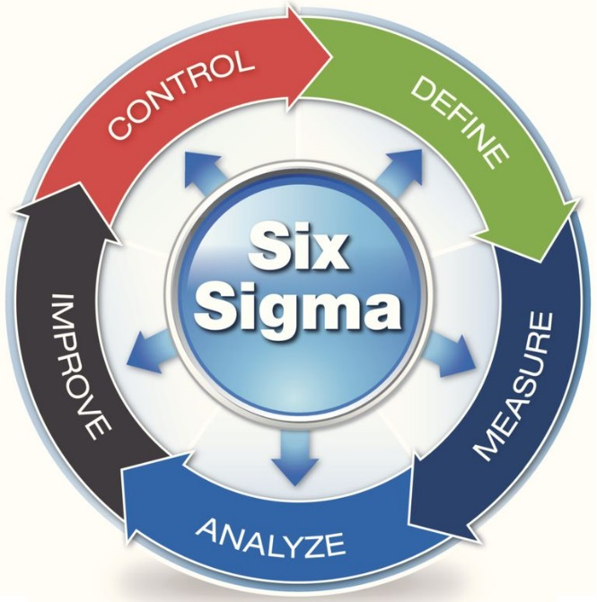
Figure 4.2 - Scheme of the Six Sigma methodology

  - Lean Six Sigma

Combining the minimalist approach of Lean (“no waste!”) and the quality improvement of Six Sigma (“zero defects!”), Lean Six Sigma focuses on eliminating waste so that projects are more efficient, cost effective, and truly answer customers’ needs.

- Other Methodologies

  - PRiSM

What is PRiSM?
PRiSM stands for Projects integrating Sustainable Methods, and, as the name suggests, it aims to take environmental factors into account. The PRiSM methodology is used primarily on large-scale construction projects, such as real estate developments, where adverse environmental impacts are a very real danger. PRiSM actually requires project managers to gain accreditation, ensuring the methodology is administered properly and retains its value.

Advantages of PRiSM
If your company wants to walk the walk when it comes to sustainability and environmental consciousness, then this is the project management methodology to choose. Show stakeholders that you’re serious about your eco-ideals, and reap the benefits of reduced energy, waste management and distribution costs.

Disadvantages of PRiSM
PRiSM cannot work in isolation. Every level of the company needs to be on board with sustainable principles, or the methodology will fall flat.

  - Benefits Realization

From conception to execution to delivery and beyond, the Benefits Realization methodology focuses on whether your deliverable satisfies the benefits the customer is expecting to get from it, not just whether or not a product was delivered on time or within budget. This methodology ensures that you deliver real value to customers and stakeholders.

  - Assignment brief
Assignment Brief |  |  |  | Academic Year ……………
Module Code and Title: |  | FABLAB Project Management |  | Module Leader:
Assignment No. and Type: |  | CW1 |  | Assessment Weighting: | 100%
Submission Date: |  |  |  | Target Feedback Date:
Assignment Task
Produce a 3,000 word Report describing the process by which a team of 4students have developed a new product, designed to be sold to households, within the FABLAB

This assignment has been designed to provide you with an opportunity to demonstrate your achievement of the following module learning outcomes:
LO 1 | Critically evaluate approaches to the problem solution from the problem definition, through selection of a solution method up to the evaluation of the final product.
LO 2 | Employ co-operative and synergistic approaches to team work, problem solving and opportunity development.
LO 3 | Employ critical judgment, select tools, methodologies, key theories and critical discourses that are appropriate to particular innovative ideas.
LO4 | Utilize creative risk taking and experimentation, learn from failure and understand the implications of the actions.

Task requirements
You are to prepare a Product Development Report

This report could be structured in the following way:
1. Describe the method and the process by which the team has been selected.
2.Describe the way in which the Product concept has been produced through collaborative work
3. Describe the way in which the design of the product has been produced including the selection criteria
4. Describe the processes used to manufacture the product within the FABLAB
5. Describe the costs incurred and the financial forecast for mass distribution
6. Describe the way in which the product was tested in the market and the modifications to the design and processes determined by the testing of the product
7. Describe the final product and its main features
8. Insert the text of the 2 minute pitch to a potential investor

Note: this report adopts a practical ‘real-world’ management format. It is, however, also an academic coursework. Accordingly at each step, ensure that:
- The logic behind your assumptions are explained clearly and critically; and
- The approach is supported by evidence in the form of references to academic theory and practice. Particular value is placed on academic journals.

Referencing and research requirements
Please reference your work according to the Harvard style as defined in Cite Them Right Online (http://www.citethemrightonline.com). This information is also available in book form: Pears, R. and Shields, G. (2016) Cite them right: the essential reference guide. 10th ed. Basingstoke: Palgrave Macmillan. Copies are available via the university library.
How your work will be assessed
Your work will be assessed on the extent to which it demonstrates your achievement of the stated learning outcomes for this assignment (see above) and against other key criteria, as defined in the University’s institutional grading descriptors. If it is appropriate to the format of your assignment and your subject area, a proportion of your marks will also depend upon your use of academic referencing conventions.
Criteria and weighting:
1. Description of the method and the process by which the team has been selected-level of detail, terminology, reference to existing literature, clarity of description. Weighting12.5%
2.Description of the way in which the Product concept has been produced through collaborative work-clarity of description, relevance, reference to existing literature, terminology- Weighting12.5%
3. Description of the way in which the design of the product has been produced including the selection criteria: clarity and succinctness, reference to relevant existing literature, description of the tasks of the team members and contribution. Weighting12.5%
4. Description of the processes used to manufacture the product within the FABLAB: succinctness, details, relevance, adequate terminology, chronological sequence of events, description of team-members’ contribution. Weighting12.5%
5. Description of the costs incurred and the financial forecast for mass distribution: Use of relevant terminology, accuracy of costs and forecasting, realistic costs and adequate forecasting method. Weighting12.5%
6. Description of the way in which the product was tested in the market and the modifications to the design and processes determined by the testing of the product: succinctness, relevance of description, chronological sequence and description of lessons learned. Weighting12.5%
7. Description of the final product and its main features. Technical detail, terminology, comprehensiveness and quality and relevance of the drawings/images. Weighting12.5%
8. The text of the 2 minute pitch to a potential investor: succinctness, clarity, relevance and comprehensiveness

This assignment will be marked according to the grading descriptors for Level 7.

Submission details
- This assignment must be submitted electronically by 2pm on the submission date
- To submit electronically you must upload your work to the e-submission area within the Blackboard module concerned. Click Submit>Browse (find the correct file to upload) Upload>Submit
- You can resubmit your work as many times as you like until the deadline. If you choose to resubmit, your earlier submission will be replaced, and you will NOT receive an Originality Report until 24 hours from when the submission was made.
- You will receive a digital receipt as proof of submission. This will be sent to your Bucks e-mail address; please keep this for reference.
- You are reminded of the University’s regulations on cheating and plagiarism. In submitting your assignment you are acknowledging that you have read and understood these regulations.
- Late submission within 10 working days of the deadline will result in the mark being capped at a maximum of 40%. Beyond this time the work will not be marked.
- You are reminded that it is your responsibility to keep an electronic copy of your assignment for future reference.

- You are reminded of the University’s regulations on academic misconduct, which can be viewed on the University website: In submitting your assignment, you are acknowledging that you have read and understood these regulations.

Submission date and time
This assignment should be submitted before ……………… time on ……………………….
Work that is submitted up to 10 working days beyond the submission date will be accepted as a late submission. Late submissions will be marked and the actual mark recorded, but will be capped at the pass mark (typically 40%), provided that the work is of a passing standard. Work submitted after this period will not be marked and will be treated as a non-submission.
Feedback and marks for this assignment will be available by date………………………………….

