OP 3.2.6
RAPID PROTOTYPING IN ELECTRONICS

Version 1.0

This training course was developed within the framework of the implementation of the program of the European Commission Erasmus+ “Development of a Network Infrastructure for youth innovation entrepreneurship support on FabLab platforms” (561536-EPP-1-2015-1-UK-EPPKA2-CBHE-JP)
http://fablab-erasmus.eu/

The European Commission support for the production of this publication does not constitute an endorsement of the contents which reflects the views only of the authors, and the Commission cannot be held responsible for any use which may be made of the information contained therein.

Information about this document
Grant Agreement Number | 561536-EPP-1-2015-1-UK-EPPKA2-CBHE-JP |  |  | Acronym |  | FabLab
Full title | Development of a network infrastructure for youth innovation entrepreneurship support on FabLab platforms
Topic | ERASMUS+ CBHA
Start date | 15 October 2015 | Duration |  |  | 36 months
Project URL | http://fablab-erasmus.eu/
Project Coordinator | Dr. Dorin Festeu, Buckinghamshire New University, United Kingdom
Work Package | WP3 – TRAINING COURSES DEVELOPMENT
Project Coordinator | BNTU (P8) |  | Email | vtrepachko@bntu.by
 |  |  | Phone | +375 29 190 95 95
 |  |  | Skype address | vmtrepachko
Responsible Author
Reviewer(s): | All partners
Keywords | Rapid prototyping, electronics, manufacturing printed circuit boards, PCB design, open hardware concept, electrical components, electronics Design Automation software

Document History
Version | Issue Date | Stage | Changes | Contributor
1.0 | 15/03/2019 | Final | Course content (preparing the first course version) | P12 (IASA NTUU “KPI”) and P4 (Universitat de València)

Contents
Course description 5
Learning outcomes 5
Course contents 5
Recommended literature 6
Planned teaching activities and teaching methods 7
Methods, criteria and procedure for evaluation 8
Skills and personal development 8
1. RAPID PROTOTYPING IN ELECTRONICS 9
1.1. Open Source Hardware market and Fablabs 9
1.2. History of Embedded Electronics 10
1.3. Microcontrollers 11
1.4. New electronic hardware product development process 12
1.5. Anatomy of a circuit board 15
1.5.1. PCB design 18
1.5.2. PCB manufacturing for hobbyist 19
1.5.3. Industrial PCB manufacturing 19
1.6. Components 20
1.6.1. Component Selection checklist 20
1.6.2. Components: packaging 21
2. PRACTICAL IMPLEMENTATIONS 23
2.1. Practical implementation of Wi-Fi enabled programmable thermostat 23
2.1.1. Requirements 23
2.1.2. Schematic and PCB development 25
2.1.3. Homeostat - code concept 29
2.2. Practical implementation of smartphone managed mobile robotic moving platform 36
2.2.1. Basic platform requirements 36
2.2.2. Components 37
2.2.3. Platform general design 39
2.2.4. Platform program part and configuration 40

Course description
Course title: | Rapid prototyping in electronics
Course unit code | Rapid prototyping in electronics
University delivering the course: | IASA NTUU “KPI Igor Sikosky”
Course type | Optional
Course level | Bachelor and Master
Number of ECTS credits | 3 credits
Mode of delivery | lectures, practical lessons, seminars, individual work, distance learning
Prerequisites and co-requisites: | students, who can sign for this course, should have at least two finished grades in engineering or computer areas

Learning outcomes
Learning objectives:
Familiarize students with the basic technologies of rapid manufacturing of devices using electronic components like microcontrollers, other electrical and mechanical components and other various equipment;
Prepare students for the creation of devices for solving practical scientific and technical problems using the whole stack of technologies starting with creation of schematics and circuits design, finishing with prototyping own PCB, and combination with mechanical pieces;
Provide students with the detailed knowledge of the equipment, software and components used for electrical rapid prototyping;
Familiarize students with the base components packaging technologies, and factors that affect the quality of final device;
Show practical examples how complicated electro-mechanical (mechatronic) devices (like robotic platform and smart thermostat) can be created;
Develop design skills and creativity among students.

As a result of successful mastering of the course, the student should know:
The basic technologies of rapid prototyping in electronics;
Obtain knowledge in PCB design process;
Learn equipment used for PCB manufacturing;
Get skills for using rapid prototyping software tools;
Increase the quality of final developed device;
Understand how complex electro-mechanical systems can be built using modern software and processes.

Course contents
1 ELECTRONICS AND RAPID PROTOTYPING
1.1 Open Source Hardware market and Fablabs
1.2 History of Embedded Electronics
1.3 Microcontrollers
1.4 New electronic hardware product development process
1.5 Anatomy of a circuit board
1.5.1 PCB design
1.5.2 PCB manufacturing for hobbyist
1.5.3 Industrial PCB manufacturing
1.6 Components
1.6.1 Component Selection checklist
1.6.2 Components: packaging
2 PRACTICAL IMPLEMENTATIONS
2.1 Practical implementation of Wi-Fi enabled programmable thermostat
2.1.1 Requirements
2.1.2 Schematic and PCB development
2.1.3 Homeostat - code concept
2.2 Practical implementation of smartphone managed mobile robotic moving platform
2.2.1 Basic platform requirements
2.2.2 Components
2.2.3 Platform general design
2.2.4 Platform program part and configuration

Recommended literature
Main:
  - Pearce, JM (2014). Laboratory equipment: Cut costs with open-source hardware. Nature 505(7485): 618.DOI: https://doi.org/10.1038/505618d
  - Irwin, JL, Oppliger, DE, Pearce, JM and Anzalone, G (2015). Evaluation of RepRap 3D Printer Workshops in K-12 STEM. 122nd ASEE Conf. Proceedings. paper ID#12036.
  - Wijnen, B, Anzalone, GC and Pearce, JM (2014a). Open-source mobile water quality testing platform. Water Sanit. Hyg. Dev 4(3): 532.DOI: https://doi.org/10.2166/washdev.2014.137
  - Zhang, C, Anzalone, NC, Faria, RP and Pearce, JM (2013). Open-source 3D-printable optics equipment. PLoS one 8(3): e59840.DOI: https://doi.org/10.1371/journal.pone.0059840
  - Analog Circuit Design: Art, Science and Personalities (EDN Series for Design Engineers): Jim Williams: 9780750696401: Amazon.com: Books
  - Design of Analog CMOS Integrated Circuits: Behzad Razavi: 9780072380323: Amazon.com
  - Digital Integrated Circuits: A Design Perspective: Rabaey: 9788120322578
  - The Circuit Designer's Companion, Second Edition (EDN Series for Design Engineers): Tim Williams: 9780750663700
  - The Art of Electronics: Paul Horowitz, Winfield Hill: 9780521809269
  - Switching Power Supplies A - Z, Second Edition: Sanjaya Maniktala: 9780123865335
  - BBC Shock and Awe The Story of Electricity 1of3. Documentary series about all great minds who ended up creating modern electronics such as Volta, Tesla, Edison, Bose, Shockley etc.
  - Jeremy Blum tutorials on Arduino.
Additional literature:
- John F. Wakerly. - Digital Design: Principles and Practices, 4th Edition,
Pearson, 2014, 895p. ISBN-13: 978-0131863897
- Wirth N., Digital Circuit Design for Computer Science Students. An Introductory Textbook. – Springer-Verlag, Berlin Heidelberg, 1995. – 204 c.
- Новиков Ю.В. Введение в цифровую схемотехнику. – М.: , 2007. – с.343
- Новиков Ю. В. Основы цифровой схемотехники. Базовые элементы и схемы. Методы проектирования. – М.: Мир, 2001. – 379 с.
- Угрюмов Е. П. Проектирование элементов и узлов ЭВМ: Учеб. пособие для вузов. – М.: Высшая школа, 1987. – 318 с.
- Угрюмов Е. П. Цифровая схемотехника.Учеб. пособие для вузов. - СПб.: БХВ – Санкт-Петербург, 2000. – 528 с.
- Угрюмов Е. П. Цифровая схемотехника. Учеб. пособие для вузов. – 2-е изд.,- СПб.: БХВ – Петербург, 2004. – 800 с.
- Схемотехника электронных систем. Цифровые устройства/Авторы: В.И. Бойко и др. – СПб: БХВ-Петербург, 2004. – 512 с.
- Компьютеры: Справочное руководство. В 3-х т. Пер. с англ. /Под ред. Г.Хелмса. – М.: Мир, 1986. – т.1- 416 с.
- Алексенко А.Г., Шагурин И.И. Микросхемотехника. – М.: Радио и связь, 1990. – 496 с.
- Алексенко А.Г. Основы микросхемотехники. - 3-е изд., перераб. и доп. - М.: ЮНИМЕДИАСТАЙЛ, 2002. – 448 с.
- Алексеенко А.Г. Основы микросхемотехники. – М.: Сов.радио, 1977. – 408 с.
- Микроэлектронные схемы цифровых устройств. – 3-е изд. перераб. и доп./ И.Н. Букреев, В.И. Горячев, Б.М.Мансуров. – М.: Радио и связь, 1990. – 416 с.
- Схемотехника ЭВМ/А.Т. Воронин, В.И. Зуев, В.И. Кальнин и др./Под ред. Г.Н. Соловьева. – М.: Высшая школа, 1985. – 512 с.
- Бирюков С.А. Применение цифрових микросхем серий ТТЛ и КМОП. – ДМК, 1999. –240 с.
- Будинский Я. Логические цепи в цифровой технике. Пер. С чешск. К.Юнга. Под ред. Б.А. Калабекова. М.: Связь, 1977. – 392 с.
- Янсен П. Курс цифровой электроники: В 4-х т. Пер. с голл. – М.: Мир, 1987.
- Гитце У., Шенк К. Полупроводниковая схемотехника: Справочное руководство. Пер. с нем. – М.: Мир, 1982. – 512 с.
- Шило В.Л. Популярные цифровые микросхемы: Справочник. – М.: Радио и связь, 1987. – 352 с.
- Юшин А.М. Цифровые микросхемы для электронных устройств: Справочник. – М.: Высшая школа, 1993. – 176 с.
- Хоровиц П., Хилл У. Искусство схемотехники. Пер. с англ..5-е изд. перераб. – М.: Мир, 1998. – 704 с.
- Соловьев В.В. Проектирование цифровых систем на основе программируемых логических интегральных схем. – М.:Горячая линия-Телеком, 2001. – 636 с.
- Хокинс Г. Цифровая электроника для начинающих: Пер. с англ. – М.: Мир, 1986. – 232 с.

Internet materials:
  - http://www.circuitbasics.com/make-custom-pcb/
  - http://pcbshopper.com/
  - http://mouser.es
  - http://www.farnell.com
  - http://www.digikey.com/
  - https://nodemcu.readthedocs.io/
  - https://en.wikipedia.org/wiki/Lua_(programming_language)
  - https://www.parallax.com/product/28962
  - https://www.dfrobot.com/product-1044.html
  - http://www.wavesen.com/probig.asp?id=24
  - https://store.arduino.cc/arduino-uno-rev3
  - http://remotexy.com/en/
  - http://itm.kpi.ua/proekti-fab-lab/mobilna-platforma-z-keruvannyam-vid-smartfona/

Planned teaching activities and teaching methods
Practical training of students is suggested, which is implemented through:
1. Discussion of projects.
2. Organization of projects proposed by students.
3. Mutual learning.
4. Self-assessment and assessment by fellow students.
5. Invited lecturers.
6. Group discussions, reviews and critical evaluations.
7. Work on real projects.
8. Mentoring.
9. Self-education.

For flexible learning:
The teacher conducts webinars, which represent the methodology and the conceptual base for students' education. Slides and course materials are available electronically. Webinars are used to strengthen knowledge of new methods and approaches, as well as to study their application in specific complex situations. Students are invited to ask questions and discuss materials in the real time online communication. To organize communications, an internet forum (message board) is used. Students can post questions and the teacher will monitor these discussions. The main emphasis is on independent learning.

Methods, criteria and procedure for evaluation
Progress and training are assessed not only at the end, but throughout the course. The ability to think and analyze problems will be assessed.
Students’ grades will be determined through reports on individual assignments after each section with a presentation of prototypes. The relative weight of each report will be set at 100%, and, in addition, the weight of the evaluation will include:
Description – 20 %;
The analysis of mistakes of created designs of devices schemes– 30 %;
Use of adequate terminology – 10 %;
Availability of a working prototype – 40 %.

Skills and personal development
The course provides the ability of students:
Prepare and set up the software for device designing;
Choose the material and needed components for the device;
Make a model of device, model PCB layout, manufacture PCB, select required components and solder all elements;
Use the gained knowledge to solve practical scientific and technical problems.

- RAPID PROTOTYPING IN ELECTRONICS
  - Open Source Hardware market and Fablabs

Open Source Hardware market worth was estimated $1billion in 2015 (50M$ in 2013).
Top commercial companies in the space, all with revenues of approaching or over $1million are: Adafruit, Arduino, Bug Labs, Chumby, Dangerous Prototypes, DIY Drones, Evil Mad Scientist Labs, Liquidware, Makerbot, Maker Shed, Parallex, Solarbotics and Sparkfun Electronics.
The rise of Free and Open Source models for software development has catalysed the growth of Free and Open Source hardware (also known as “Libre Hardware”). Libre Hardware is gaining significant traction in the DIY, SME and scientific hardware communities, where there is evidence that open development creates both technically superior and far less expensive scientific equipment than proprietary models.
Collaborative practice of sharing digital designs have reduced the capital costs of such Libre Hardware to an unprecedented 90–99% decrease from the cost of functionally-equivalent proprietary equipment (Pearce, 2014). Consider three examples. First, replacing a $2,000 hand-held water quality tester can be done for under $100 if Open Source electronics and 3D printed parts are used (Wijnen, et. al. 2014). The RepRap used for fabricating the water quality tester costs less than $500 (Irwin, et al., 2015). Thus, even if only a single water quality tester is printed, the costs of the open source 3D printing manufacturing technology are more than justified for the scientist. Similarly, the majority of mechanical fixtures for optics labs in physics research and education can be replicated from common 3D printed plastic. A $15,000 optics lab can be reduced to a $500 3D print job (Zhang, et al., 2013) on a sub-$500 3D printer. Such savings can scale to many research laboratories once the initial designs are produced and licensed with Open Hardware licenses. For example, biologists, chemists, and biochemists can print a syringe pump and automate it for under $100 replacing traditional syringe pumps which range from $250 for low-end pumps to over $5000 for sophisticated ones (Wijnen, et al., 2014).
It can be stated that the practice of using custom hardware in different projects is common. For example, 6 of 24 most successful Ukrainian startups (like Ecoisme, Hideez, UniExo, Petcube etc.) are making electronic devices. Thus, FABLABs infrastructure can become a great fit for open source hardware market taking part in production and rapid prototyping cycle.
In addition, FABLABs can be used for education: as an example see 2015 UK computer literacy project; where every 11-12 year old child can get a Micro Bit electronics kit and start making prototypes of different devices.
Additional information:
Pearce, JM (2014). Laboratory equipment: Cut costs with open-source hardware. Nature 505(7485): 618.DOI: https://doi.org/10.1038/505618d
Irwin, JL, Oppliger, DE, Pearce, JM and Anzalone, G (2015). Evaluation of RepRap 3D Printer Workshops in K-12 STEM. 122nd ASEE Conf. Proceedings. paper ID#12036.
Wijnen, B, Anzalone, GC and Pearce, JM (2014a). Open-source mobile water quality testing platform. Water Sanit. Hyg. Dev 4(3): 532.DOI: https://doi.org/10.2166/washdev.2014.137
Zhang, C, Anzalone, NC, Faria, RP and Pearce, JM (2013). Open-source 3D-printable optics equipment. PLoS one 8(3): e59840.DOI: https://doi.org/10.1371/journal.pone.0059840

  - History of Embedded Electronics
An embedded system is a combination of computer hardware and software, either fixed in capability or programmable, designed for a specific function or functions within a larger system. Industrial machines, agricultural and process industry devices, automobiles, medical equipment, cameras, household appliances, airplanes, vending machines and toys, as well as mobile devices, are possible locations for an embedded system.
Embedded systems are computing systems, but they can range from having no user interface (UI) -- for example, on devices in which the system is designed to perform a single task -- to complex graphical user interfaces (GUIs), such as in mobile devices. User interfaces can include buttons, LEDs, touchscreen sensing and more. Some systems use remote user interfaces as well.
Embedded systems date back to the 1960s. Charles Stark Draper developed an integrated circuit (IC) in 1961 to reduce the size and weight of the Apollo Guidance Computer, the digital system installed on the Apollo Command Module and Lunar Module. The first computer to use ICs, it helped astronauts collect real-time flight data.
In 1965, Autonetics, now a part of Boeing, developed the D-17B, the computer used in the Minuteman I missile guidance system. It is widely recognized as the first mass-produced embedded system. When the Minuteman II went into production in 1966, the D-17B was replaced with the NS-17 missile guidance system, known for its high-volume use of integrated circuits. In 1968, the first embedded system for a vehicle was released; the Volkswagen 1600 used a microprocessor to control its electronic fuel injection system.
Further historical milestones were:
• 1970s – Integrated Circuits become affordable for small business and amateurs;
• 1990s – Microcontroller revolution. Small automation goes digital;
• 2000s – Arrival of cheap and simple MCU development tools on the market;
• 2010s – Systems-on-Chip with radio become widespread. Drastic reduction of time and costs for the connected device development.
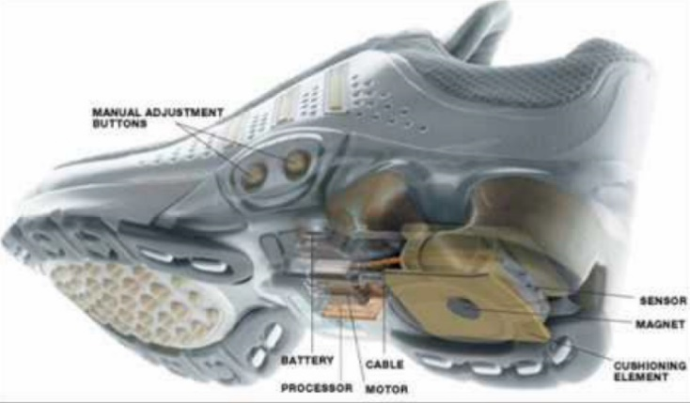
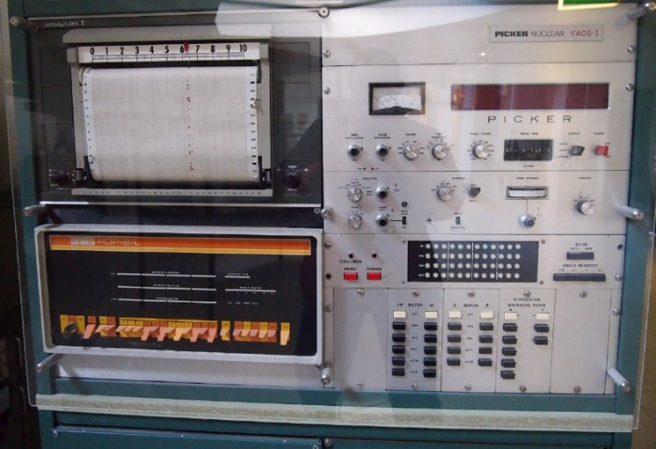

Figure 1 - For comparison: in 1976 the whole computer had to be embedded into the device and in 2016 the computer fits into a single chip and can be embedded into a shoe

  - Microcontrollers
By the late 1960s and early 1970s, the price of integrated circuits dropped and usage surged. The first microcontroller was developed by Texas Instruments in 1971. The TMS 1000 series, which became commercially available in 1974, contained a 4-bit processor, read-only memory (ROM) and random-access memory (RAM), and cost around $2 apiece in bulk orders.
Also in 1971, Intel released what is widely recognized as the first commercially available processor, the 4004. The 4-bit microprocessor was designed for use in calculators and small electronics, though it required eternal memory and support chips. The 8-bit Intel 8008, released in 1972 had 16 KB of memory; the Intel 8080 followed in 1974 with 64 KB of memory. The 8080's successor, x86 series, was released in 1978 and is still largely in use today.
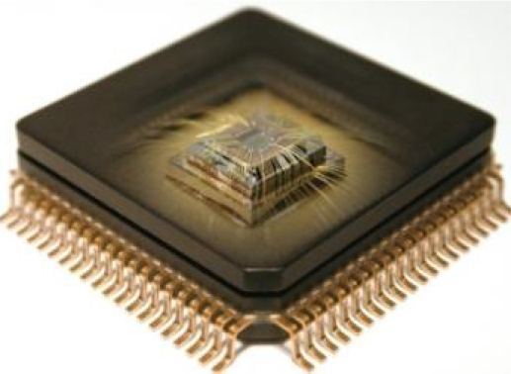
Figure 2-Inside view of microcontroller
In 1990s the implementation of a whole system on silicon chip becomes cheaper than the packaging on different separate components.
Nowadays a self-sufficient integrated circuit that can be programmed and execute the program with the minimum number of external components.

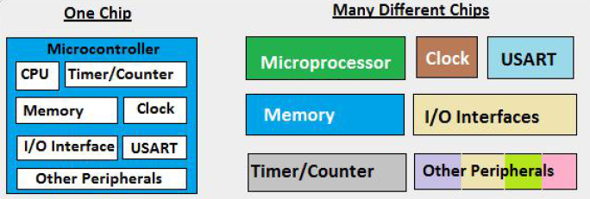
Figure 3- Due to universality, microcontrollers are mass-produced and usually are cheaper than discrete component systems.

  - New electronic hardware product development process
The new product development process for an electronic product (or any product) is by no means simple. It is an overwhelming task especially for those with limited resources such as entrepreneurs, makers, start-ups and small companies. However, the process can be simplified by breaking it down into five steps. The steps summarized below will get you to the point of having a fully functional prototype.
There are many other steps to getting a product to the point of being manufactured in volume and sold to the general public.

Development process: Create a Preliminary Production Design
General process can be shown via the next steps:
• Pinpoint existing problem to be solved or new functionality that should be added to existing process/device;
• Create device concept that will solve the problem;
• Select technologies to be used for the desired functionality;
• Detect contradicting factors and compromises to be made;
• Select necessary parts and tools to be used;
• Prototyping part;
• Debugging of the prototype. Idea evaluation;
• Preparing the prototype for the mass production.

When developing a new electronic hardware product you should first start with a preliminary production design. This is not to be confused with a Proof-of-Concept (POC) prototype. A POC prototype is usually built using a development kit like an Arduino. They can sometimes be useful to prove that your product concept solves the desired problem. However, a POC prototype is far from being a production design. Rarely can you go to market with an Arduino embedded in your product.
A preliminary production design focuses on your product’s production components, cost, profit margin, performance, features, development feasibility and manufacturability. You can use a preliminary production design to produce estimates for every cost your product will need. It is important to accurately know the costs to develop, prototype, program, certify, scale, and manufacture the product.
A preliminary production design will answer the following pertinent questions. Is my product feasible to develop? Can I afford to develop this product? How long will it take me to develop my product? Can I mass manufacture the product? Can I sell it at a profit?
Many entrepreneurs make the mistake of skipping the preliminary production design step, and instead jump right into designing the schematic circuit diagram. By doing so, you may eventually discover you have spent all this effort and hard-earned money on a product that cannot be affordably developed, manufactured, or most importantly, sold at a profit.

Prototype creation:
• Block schematic of the device. When creating the preliminary production design you should start by defining the system-level block diagram. This diagram specifies each electronic function and how all of the functional components interconnect. Most products require a microcontroller or a microprocessor with various components (displays, sensors, memory, etc.) interfacing with the microcontroller via various serial ports. By creating a system block diagram you can easily identify the type and number of serial ports required. This is an essential first step for selecting the correct microcontroller for your product.
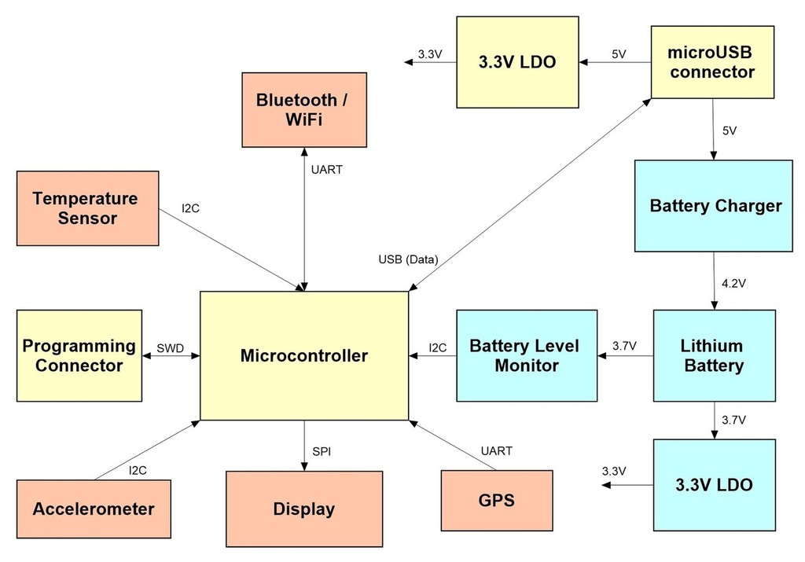
Figure 4– A block diagram specifies each function and the system-level connectivity.
• Component selection. Next, you must select the various production components: microchips, sensors, displays, and connectors based upon the desired functions and target retail price of your product. This will allow you to then create a preliminary Bill of Materials (BOM) and estimate production cost.
• CAD Schematic design. Now it’s time to design the schematic circuit diagram based upon the system block diagram you created in previous step. The schematic diagram shows how every component, from microchips to resistors, connects together. Whereas a system block diagram is mostly focused on the higher level product functionality, a schematic diagram is all about the little details. Something as simple as a mis-numbered pin on a component in a schematic can cause a complete lack of functionality. In most cases you’ll need a separate sub-circuit for each block of your system block diagram. These various sub-circuits will then be connected together to form the full schematic circuit diagram. Special electronics design software is used to create the schematic diagram and to help ensure it is free of mistakes. For example you may use a package called DipTrace which is affordable, powerful, and easy to use.
• PCB design. Once the schematic is done you will now design the Printed Circuit Board (PCB). The PCB is the physical board that holds and connects all of the electronic components. Development of the system block diagram and schematic circuit have been mostly conceptual in nature. A PCB design though is very real world. The PCB is designed in the same software that created the schematic diagram. The software will have various verification tools to ensure the PCB layout meets the design rules for the PCB process used, and that the PCB matches the schematic. In general, the smaller the product, and the tighter the components are packed together, the longer it will take to create the PCB layout. If your product routes large amounts of power, or offers wireless connectivity, then PCB layout is even more critical and time consuming.
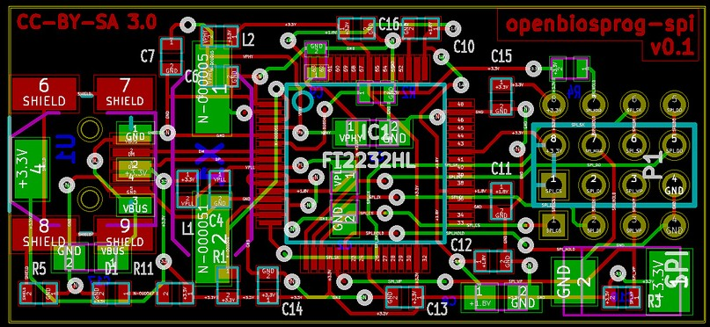
Figure 5– Example of a Printed Circuit Board (PCB) layout design
• PCB manufacturing. To actually manufacture the PCB you need a complete BOM with every component listed. This BOM is usually created automatically by the schematic design software. The BOM lists the part numbers, quantities, and all component specifications. Creating electronic prototypes is a two-step process. The first step produces the bare, printed circuit boards. Your circuit design software will allow you to output the PCB layout in a format called Gerber with one file for each PCB layer. These Gerber files can be sent to a prototype shop for small volume runs. The same files can also be provided to a larger manufacturer for high volume production.
• PCB soldering. The second step is having all of the electronic components soldered onto the board. From your design software you’ll be able to output a file that shows the exact coordinates of every component placed on the board. This allows the assembly shop to fully automate the soldering of every component on your PCB.
• MCU programming and Testing. Now it’s time to evaluate the prototype of the electronics. Keep in mind that your first prototype will rarely work perfectly. You will most likely go through several iterations before you finalize the design. This is when you will identify, debug and fix any issues with your prototype. This can be a difficult stage to forecast in both terms of cost and time. Any bugs you find are of course unexpected, so it takes time to figure out the source of the bug and how best to fix it. Evaluation and testing are usually done in parallel with programming the microcontroller. Before you begin programming though you’ll want to at least do some basic testing to ensure the board doesn’t have major issues. Nearly all modern electronic products include a microchip called a Microcontroller Unit (MCU) that acts as the “brains” for the product. A microcontroller is very similar to a microprocessor found in a computer or smartphone.
A microprocessor excels at moving large amounts of data quickly, while a microcontroller excels at interfacing and controlling devices like switches, sensors, displays, motors, etc. A microcontroller is pretty much a simplified microprocessor.
The microcontroller needs to be programmed to perform the desired functionality. Microcontrollers are almost always programmed in the commonly used computer language called ‘C’. The program, called firmware, is stored in permanent but reprogrammable memory usually internal to the microcontroller chip.

  - Anatomy of a circuit board
Printed circuit boards (PCBs) are physical components of electronic devices. They're made up of a board, which is typically resin or plastic, and solder, the conductive metal parts that channel energy, usually made of copper. The solder makes the electrical connections between the PCB and the parts of the device possible.
Printed circuit boards (PCBs) have long been the foundation of electrical engineering, serving as the “brains” of any powered device. Designing PCBs is to electrical engineering as HTML is to web development—the backbone that makes it all possible. That’s because no powered device works without a PCB of some sort. From cell phones and remote controls to robotics and toys, PCBs provide electricity and connectivity between the components of a device, allowing it to function the way it was designed.
Here’s a look at what goes into this technology and what you need to know to get started prototyping a PCB for your next embedded system project.
The foundational component of most circuit boards is the board itself, a flat piece of stiff material which needs two primary physical properties: It must be an electrical insulator, and it must be fire-resistant. The majority of circuit boards today use FR4 for the board structure itself; FR4 is a standardized material consisting of fiberglass reinforced with epoxy resin. The "FR" stands for "flame-resistant": FR4, like other FR materials, is self-extinguishing. A circuit board thus begins its life as simply a flat rectangle of FR4. Other materials do exist and are sometimes used, including FR2 and FR3, which are essentially hardened paper and have the advantage of being cheaper than FR4, but FR4 offers an excellent price-performance ratio and is generally used in nearly all professionally-manufactured and -sold circuit boards today.
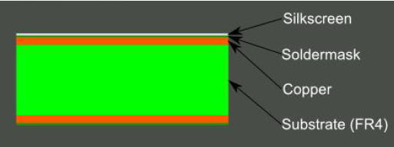
Figure 6– Layers of PCB
Once the basic board material has been produced, it is plated with copper. Some boards manufactured for the hobbyist market are plated on only one side, but most circuit boards are plated with copper on both sides; indeed, most commercial electronic products made today have multi-layer circuit boards, meaning that they are not merely coated externally, but contain an internal sandwich of several layers of copper, each separated by insulation. The thickness of the copper on the outside layers of the board varies, and is measured in ounces per square foot. Thus, a board which uses copper thickness of one ounce of copper per square foot is said to have "one ounce copper." Circuit boards are usually either half-ounce copper, one-ounce copper, or two-ounce copper. Half-ounce copper is typically fine for low-power applications; thicker copper may be desired for circuit boards which carry some appreciable amount of electrical power, since high amounts of current will cause the copper to heat up, creating the risk of fire if thin copper is used.
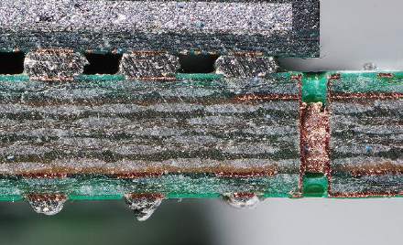
Figure 7–View of multi-layer circuit board side cut with several layers of copper, each separated by insulation.

Circuit boards which are fully covered with copper plating are sold to the hobbyist market for people to create their own circuit boards with. These boards are nothing more than FR4 (or a similar material) with copper plating. From this point, the primary steps that remain in turning this product into a finished circuit board are drilling and etching. Additional optional steps are laminating and screen printing. Once these have been finished, the final step is component population.
It is technically possible to perform either the drilling of the board before the etching, or the etching before the drilling. However, in general, it is recommended to drill the holes in the board before performing the etching; if conductive holes are drilled after etching has been performed, the hole is being drilled through a small pad of copper that has been glued to the board, and there is risk of the copper pad being torn off the board.
Most circuit boards have several holes drilled through them in specific locations to make interconnections between the different layers of the board. Holes are also drilled to provide housings for through-hold components (components with pins which pass through the circuit board before being soldered), but as through-hole components have largely been replaced by surface-mount components (components whose pins simply solder to pads on the surface of the circuit board rather than passing through it), this is less common nowadays, although through-hole components are still widely used on hobbyist circuit boards. Professionally-made boards have their holes custom-drilled before being copper plated, resulting in the holes themselves being plated around their inner circle. Since hobbyists drill their boards after the boards have already been plated, their holes end up having connections only on the external surface of the board, not along the interior of the holes themselves.
Etching the circuit board is the process of removing excess copper, leaving the traces that form the wiring of the printed circuit. Etching is usually done by immersing the board into a corrosive acid which burns the unwanted copper off the board. Prior to immersion, the circuit pattern is painted or coated onto the board with "etch resist," a material (typically some sort of plastic) which resists the acid and will leave the parts of the copper which you want to keep. After the unwanted copper has dissolved, the board is cleaned off and the etch resist is removed.
At this point, the circuit board has its circuit pattern formed, and many cheap or hobbyist boards are "finished" at this point. Professionally-made boards, however, usually go through additional steps.
At a minimum, most circuit boards today are laminated with "solder mask" or "solder resist," which is a plastic formulated to endure high temperatures without melting. The solder resist serves two primary functions: First of all, it protects the external traces on the surface of the board, preventing them from making electrical contact with anything which might touch the board and also protecting them from mechanical damage such as scratches. Secondly, the solder resist, as its name suggests, resists adhesion with hot solder, which helps prevent solder bridges between pads which are adjacent to each other. Hobbyists who create boards with fine-pitch surface-mount chips without a solder mask over the board run a high risk of inadvertent solder bridges between pins.
The solder mask also lends the final color to the board. Most people think of circuit boards as being green; what they are actually seeing is the green solder mask that the board has been plated in. Because the solder mask is a plastic, it can be any color, and indeed, circuit boards do exist in all the primary colors, but green is the most popular color, for historical reasons which aren't clear. A variety of stories, most of them completely unsubstantiated, circulate regarding why green became such a popular color, but these stories generally veer into the realm of folk legends; today, green remains a popular color simply because it is more expensive to use other colors, since the plastic used in solder masks is mixed in batches and using different colors requires "special," lower-volume batches to be mixed, which incurs greater expense. Green thus remains popular because of its "momentum" due to its heavy use in the past, a momentum that is both cultural and economic. Technically speaking, there is no requirement for the solder mask to be any specific color.
The circuit board is also often "screen printed" or "silkscreened" with text (which is almost always white in color). This text is purely for visual purposes and serves no technical purpose in terms of the function of the board itself. At a minimum, the silkscreen layer is usually used to indicate the identities of the various component locations on the board (for example, "R1" would be printed somewhere on the board to indicate the location of the first resistor). Sometimes various notes and information for users is printed directly on the board itself in this fashion. Identifying information such as a company name, product model number, copyright date, and so on are also common. Some designers may also get creative and use the silkscreen layer for artistic purposes, since the end-user may come into contact with the board at some point. The silkscreen may also be used to provide location-tracking information for automated component-placing machines, since such machines often use visual cues to determine where components are to be placed on the board.
Populating the board with components (resistors, capacitors, inductors, integrated circuits (chips), and so on) is the final step in producing an actual finished board. Most manufacturing houses that manufacture printed circuit boards do not perform this step since component assembly uses completely different equipment and processes than the previous steps, and so the unpopulated circuit boards are often sold as "finished" boards. Either way, once the various components have been soldered to the board, the board is complete.

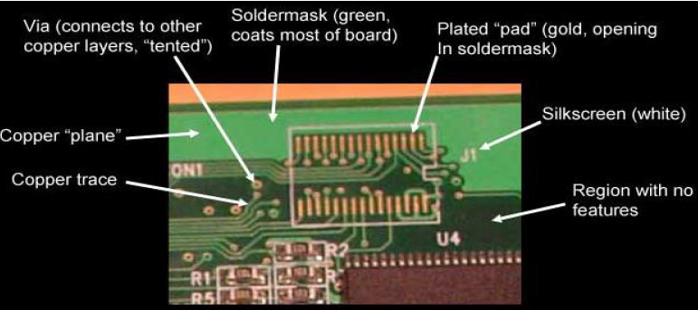
Figure 8– PCB parts

    - PCB design
To design a printed circuit board you need to follow the next steps:
• “Device design first” - the mechanical dimensions and the shape of the PCB must be defined beforehand;
• Connectors, board mount elements: placement, size, shape must be selected to suit your needs and performance parameters;
• Heat – in case of casing of your PCB – think how heat will be removed;
• EMC/crosstalk
The detailed tutorial how to design a PCB board can be found here: http://www.circuitbasics.com/make-custom-pcb/
In this tutorial, you’ll see the process of designing a PCB layout and getting it printed by a custom PCB manufacturer. The performance of your circuit will depend greatly on how it’s laid out on the PCB, so lots of tips on how to optimize your design will be given.

    - PCB manufacturing for hobbyist
Traditionally, there are two ways of hobbyists making custom PCBs:
1. Using toner transfer (LUT) and chemical etchant -- can be tricky to get the right materials, and the chemicals are nasty and messy. Average resolution (up to 0.2 mm);
2. Paying a service like BatchPCB or OshPark -- fairly inexpensive, but usually have to wait a long time, like two or three weeks.
Milling them on a CNC is a quick way with a different set of pros and cons:
The good:
- Quick turnaround - don't have to wait days or weeks for it to ship;
- The mill does the drilling;
- No messy acid to deal with;
- Once you have good settings, the process is easily repeatable;
- Two sided boards are possibly slightly easier than with etched boards;
- Inexpensive - you're just paying for blank circuit boards which are a couple bucks each.

The not so good:
- Bits and end mills can be expensive and they wear out;
- Bits of copper clad fiberglass get all over the place;
- Milling a board can take a while;
- Board stock and mill bed flatness will present a challenge;
- Isolation size is a function of bit size and mill accuracy. Check your design carefully before you plan on using fancy SMT parts with densely packed pins.
- Lots of manual work

    - Industrial PCB manufacturing
For industrial PCB manufacturing mostly photoresistive method is used that with the help of light sensitive components creates protective layers resistant to chemicals while unprotected parts of PCB are corroded and create desired layout. Multiple repetitions of the procedure can produce board of any complexity.
The good:
- Best detailization (up to 0.05 mm)
- Manufacturing of high complexity PCBs
- High repeatability
- Mass production ready
The not so good:
- The machinery is very expensive (but there are solutions for home manufacturing too)
http://pcbshopper.com/

  - Components
All electronic devices comprise of several different parts. These parts work together to modify and manage current and voltage to produce the desired effect. Circuit boards act as backbones keeping everything connected and compacted in a form that is easy to use.
Most of these components are standardized off-the-shelf parts that you can quickly identify, find, and purchase with easy-to-understand shapes, sizes, and colors. Other components are more proprietary to your project, making them much more difficult to find.
An excellent schematic diagram can help you identify the parts you need and when. These drawings provide a snapshot of your circuit using symbols to represent each component type. Straight solid lines mark the wiring and connectors between components. Zigzag lines represent resistors. Capacitors are short parallel likes and so forth.
A functional schematic will also use letters and numbers to label each component's position on the circuit as well. For instance, the eleventh resistor is "R11" on the schematic etc.
Many are standardized off-the-shelf parts that you can quickly identify, find and purchase. Other components are more proprietary to your project, making them much more difficult to find. You can do PCB Assembly much easier after knowing any kinds of parts you need.

    - Component Selection checklist
Selecting components for your project you should consider the following aspects:
• Availability on the market;
• Documentation and manufacturer support;
• Price;
• Previous experience working with component;
• Mounting technology available.
All the fore mentioned (and some more) parameters necessary to be taken into account when choosing the right ones!
Let's try to find and compare parts for the digital thermometer IC on the next websites:
• http://mouser.es
• http://www.farnell.com
• http://www.digikey.com/

    - Components: packaging
Integrated circuits are put into protective packages to allow easy handling and assembly onto printed circuit boards and to protect the devices from damage. A very large number of different types of package exist. Some package types have standardized dimensions and tolerances, and are registered with trade industry associations such as JEDEC and Pro Electron. Other types are proprietary designations that may be made by only one or two manufacturers. Integrated circuit packaging is the last assembly process before testing and shipping devices to customers.
Occasionally specially-processed integrated circuit dies are prepared for direct connections to a substrate without an intermediate header or carrier. In flip chip systems the IC is connected by solder bumps to a substrate. In beam-lead technology, the metallized pads that would be used for wire bonding connections in a conventional chip are thickened and extended to allow external connections to the circuit. Assemblies using "bare" chips have additional packaging or filling with epoxy to protect the devices from moisture.
The most common types of packages are:
• THT (through-hole technology)
Through-hole technology uses holes drilled through the PCB for mounting the components. The component has leads that are soldered to pads on the PCB to electrically and mechanically connect them to the PCB.
The distinguishing features of this technology are:
  - Large size;
  - Easier to mount for inexperienced users;
  - More expensive in mass production;
  - Some elements available only in THT.
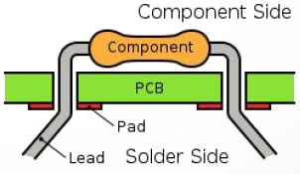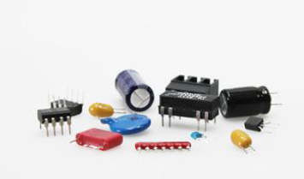
Figure 9– Example of THT components
SMD (surface mount)
Surface-mount technology (SMT) is a method for producing electronic circuits in which the components are mounted or placed directly onto the surface of printed circuit boards (PCBs). An electronic device so made is called a surface-mount device (SMD). In industry, it has largely replaced the through-hole technology construction method of fitting components with wire leads into holes in the circuit board. Both technologies can be used on the same board, with the through-hole technology used for components not suitable for surface mounting such as large transformers and heat-sinked power semiconductors.
  - Can be very small;
  - Cheaper components, cheaper board manufacturing;
  - Harder for manual assembly; special tools sometimes required.
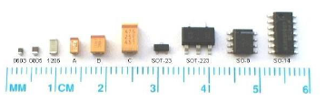
Figure 10– Example of SMD components
BGA (Ball grid array) or other no-leads package
Ball Grid Array BGA uses the underside of the package to place pads with balls of solder in grid pattern as connections to PCB
  - Smallest components and highest density on the board;
  - The only solution for high-end complex ICs, like processors;
  - Requires special equipment to solder.

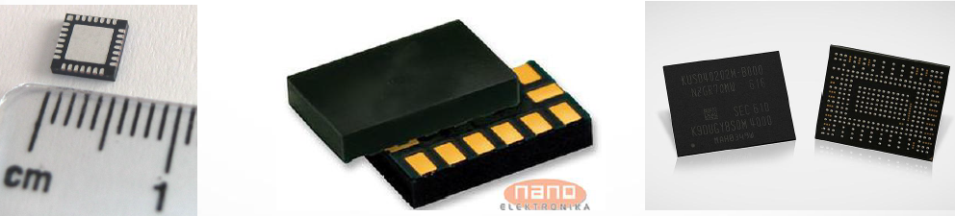
Figure 11– Example of BGA components

- PRACTICAL IMPLEMENTATIONS
  - Practical implementation of Wi-Fi enabled programmable thermostat
In this section the idea and implementation guidelines of programmable thermostat are covered. It is shown how easy to build IoT device with modern technologies and tools.
The idea of the programmable thermostat device is to monitor room temperature and send information to user devices like laptop or smartphone.
This thermostat can be used as part of smart-home giving feedback loop via API to heating/cooling inhouse systems.
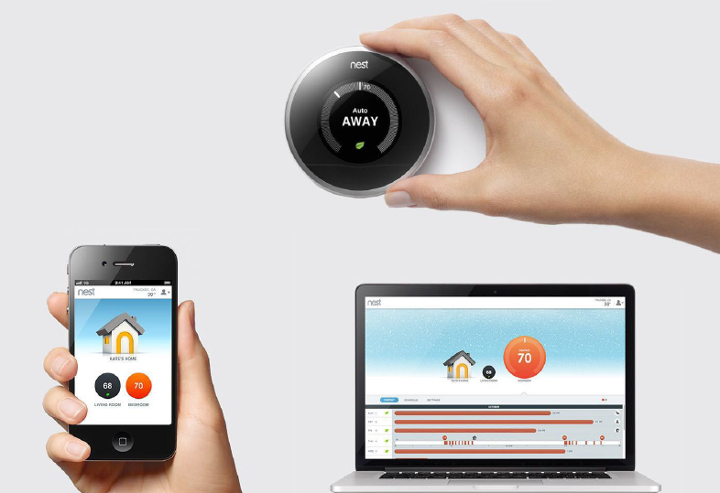

Figure 12- Wi-Fi enabled v with light sensor
    - Requirements
• Power: always on;
• Power source: external;
• Inputs: temperature sensor, luminosity sensor;
• Outputs: single on/off output;
• Programmable via computer/smartphone.

Block schematic
General block scheme of the device is shown below.
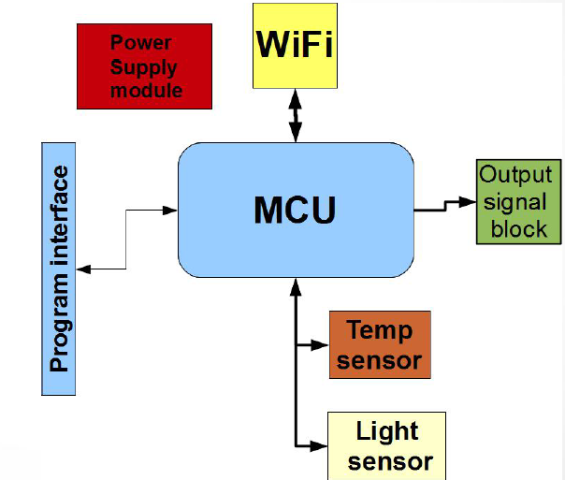
Figure 13 - Programmable thermostat general block scheme.
The final device scheme consists of the following modules:
• Power module;
• Processor;
• Wireless comm;
• Sensors;
• Output.

Selected components to be used
• Power: cheap linear regulator. Input: 5-9V, output 3.3V stable
• Processor (MCU)+wireless comm: ESP8266 SoC. Integrated WiFi solution
• Light sensor: cheap photoresistor
• Temperature sensor: digital inexpensive LM75 thermometer

ESP8266 chip
• An integrated solution, containing WiFi module and MCU in a single chip;
• Cheap (<2.5$) and easy to obtain;
• Large amount of development tools, big community available;
• Many modules available, removing the necessity to design RF part (hard one) manually;
• Firmware libraries available;

Engineer's best friend: Datasheet
Every component manufacturer provides an extensive set of documentation on its production.
Types of documentation usually provided:
      - Datasheet
      - Application note
      - Instruction manual (for processors)
      - Design guidelines
It is important to keep the latest copies of the parts' documentation with the project, many costly errors can be avoided by that

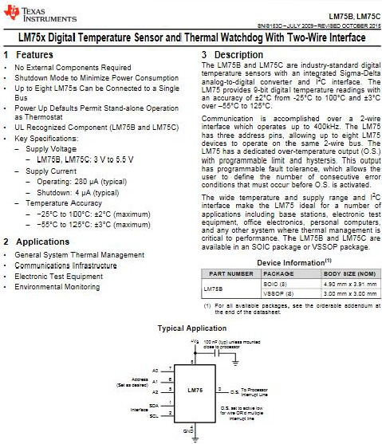
Figure 14– View of datasheet’s first page for LM75x Digital temperature sensor
    - Schematic and PCB development

Electronics Design Automation software– EDA
This tool is used for:
• Schematic creation;
• Circuit simulation (not in all EDA);
• Printed circuit board creation;
• Electrical and design rule check;
• Generation of Gerber files (data format for industrial fabrication);
• Autogeneration of documentation. EDA - programs and features CAD Eagle (now part of Autodesk);
• Free version available, includes 2 schematic sheets, 2 signal layers, and 80 cm2 board area. KiCAD - free, open-source EDA;
• Schematics of arbitrary complexity.

EDA Workflow
• The first step is drawing the electrical schematic.
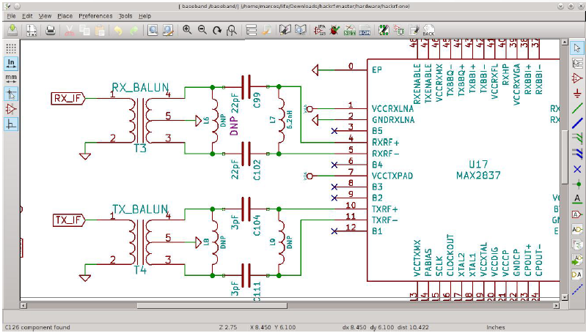
Figure 15- Drawing the electrical schematic
• After the electrical schematic is complete the next step is to find for each component its place on the PCB.
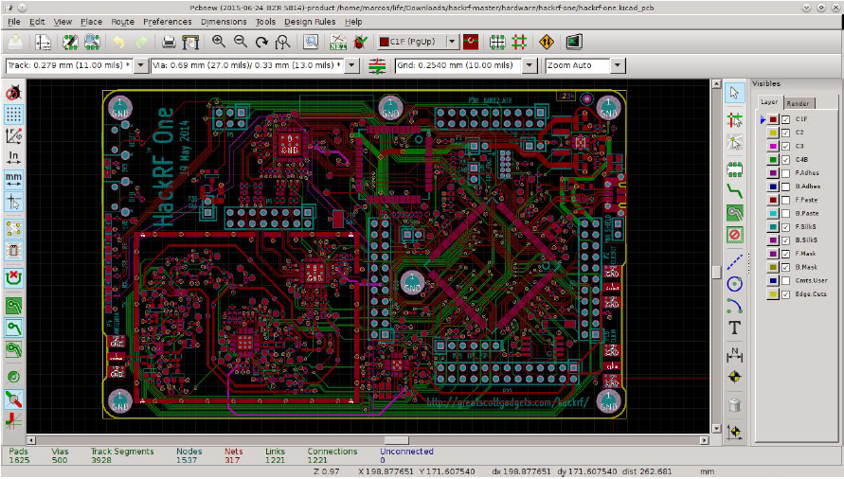
Figure 16- Printed Circuit Board design.
• Optional: with 3D view generation feature you can estimate how final board will look like.
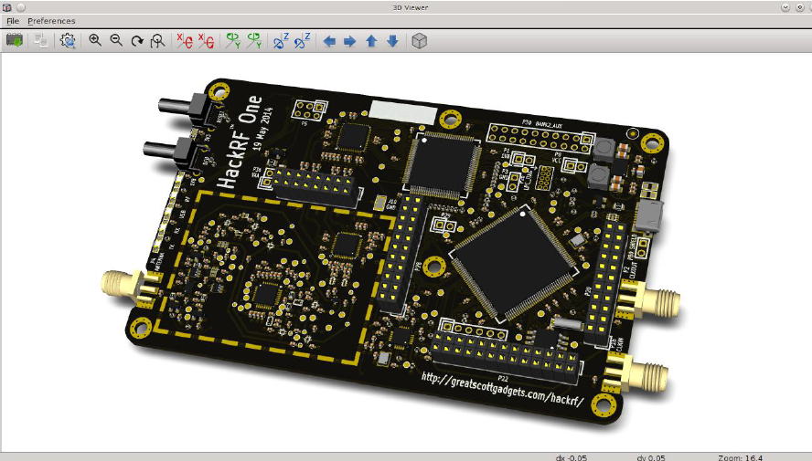
Figure 17- 3D view generation
Schematic drawing
• Prepare the libraries for the all components (and check them!);
• Place the elements on the schematic;
• Draw connections between them;
• ERC (Electric Rule Check).

Main board
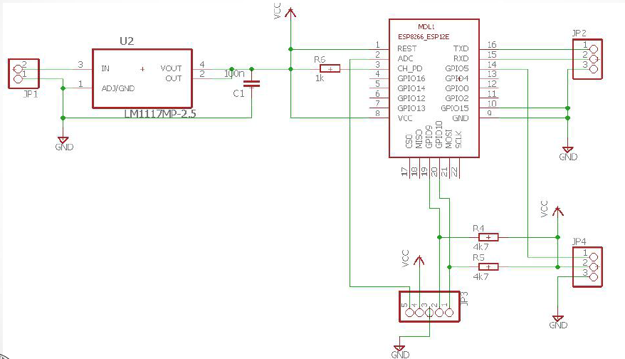
Figure 18– Thermostat main board design

EDA concepts
• Element - a physically present component of the design. The element consists of schematic symbol and footprint. In complex EDAs it may also include the 3D model and electrical
simulation model (SPICE).
• Signal - a concept of virtual wire. Sygnal is defined by its name and all elements connected to the signal with the same name will have electric connection between them.
• Power rails (VCC, GND) are just a special type of signals, despite having special symbols assigned. The board can contain several power independent power rails, if the names are different.

Sensor board
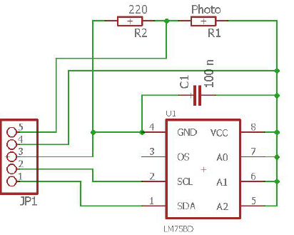
Figure 19– Sensor board design

Gerber files creation
• Gerber - simple text format for 2D binary images.
• Every layer goes to its separate file:
– .cmp : Component side (top)
– .sol : Soldering side (bottom)
– .plc : solk screen
• Drilling: Excellon format: drd
• Gerber viewers: gerbv or online

    - Homeostat - code concept

• The device measures the temperature and luminosity constantly;
• The device creates the Wi-Fi Access point;
• The user can connect to the Wi-Fi with his or her device;
• The device services a simple web page with homeostatic controls (threshold level and event type);
• If the threshold is set, the device drives the output according to the selected rule and conditions;

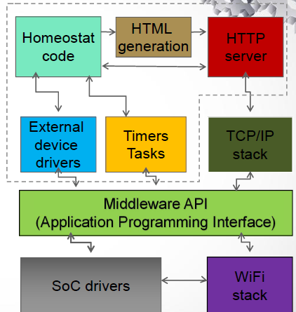
Figure 20– Homeostat high-level modules scheme

NodeMCU and Lua
NodeMCU
• Open-source IoT platform for ESP8266
• Broad set of libraries and code snippets to use
• Pseudo-RTOS environment
• https://nodemcu.readthedocs.io/
Lua scripting language
• Lightweight interpretable language
• Implemented in C, shares the C-like language
• Multi-paradigm, rich set of native language tools
• https://en.wikipedia.org/wiki/Lua_(programming_language)

ESPlorer IDE
For code development ESPlorer IDE is used.
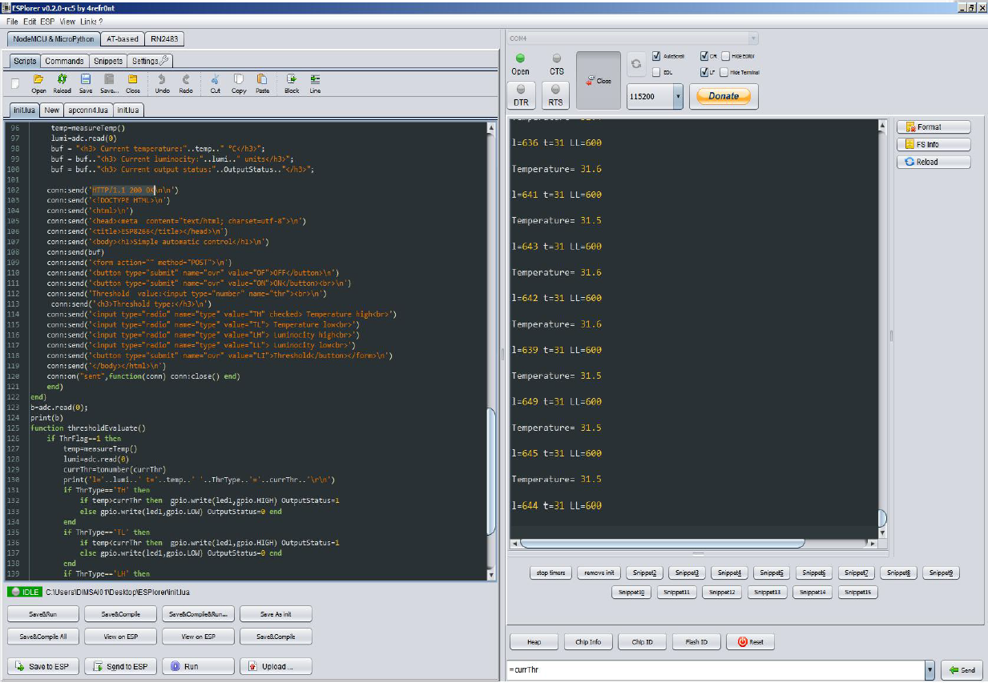
Figure 21- ESPlorer IDE used in project development

The code elements
• Wi-Fi initialization
• DHCP initialization
• Thermometer communication library (I2C)
• A simple web server (serving the page)
• The page contents (HTML)
• POST response parser
• Threshold checker and timer service routine

Wi-Fi and DHCP
• The homeostat will create a tiny access point (AP): it creates it's own network, provides the low-level communication protocol and authorization.
• Dynamic Host Configuration Protocol - an “address book” service in the network. Assigns the addresses for the connected devices and manages their configuration.
• Good news: they are provided by NodeMCU!

Reading out the thermometer
i2c.setup(0, sda, scl, i2c.SLOW)
function read_reg(dev_addr,bytes)
i2c.start(0)
i2c.start(0)
i2c.address(0, dev_addr, i2c.RECEIVER)
c = i2c.read(0, bytes) -- bytes read and returned
i2c.stop(0)
return c
end
function measureTemp()
reg = read_reg(LM75_addr,2) --for brd#3
temp=10*tonumber(string.byte(reg,1))+(tonumber(string.byte(reg,2))
/32)
print(string.format("Temperature= %d.%d \r\n",temp/10,temp-
(temp/10)*10))
return temp/10
end

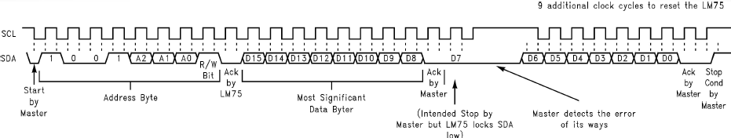
Figure 22– Pins signals timing diagram

Reading out the photo resistor
• ESP8266 has very basic 8-bit analog-digital converter that can convert the voltage in the range of 0..1.024V
• Our photoresistor range is 0.45..16 kOhm
• Out input voltage is 3.3 V
• API command: adc.read(0)

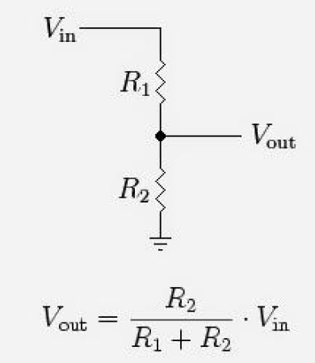
Figure 23– Photoresistor circuit diagram and voltage calculation

HTTP protocol basics
• A stateless simple “request-response” protocol.
• Computers are communicating with plain text.
• The client asks for the specific page on the server and describes what type of content it can accept.
• The server replies with the basic information about the content provided and serves the page itself.

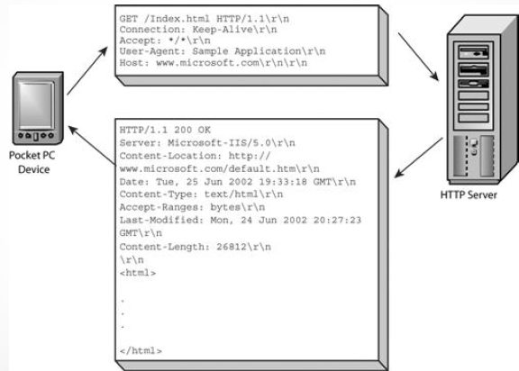
Figure 24- HTTP protocol: example

HTTP POST method
We use POST requests to submit the data to the server.
The server gets the string of parametervalue pairs, encoded as:
parameter1=value1&parameter2=value2&parameter3=value3 etc.
All values are plain text strings
The values go in arbitrary order
We need to transmit three parameters:
- Action (On, Off, Set threshold)
- Threshold type
- Threshold parameter value
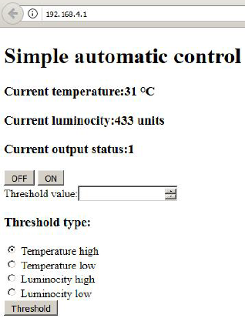
Figure 25- View of thermostat page in web browser
HTML code for our web page
<!DOCTYPE HTML>
<html>
<head><meta content="text/html; charset=utf-8">
<title>ESP8266</title></head>
<body><h1>Simple automatic control</h1>
<h3> Current temperature:" " °C</h3>
<h3> Current luminocity:"..lumi.." units</h3>
<h3> Current output status:"..OutputStatus.."</h3>
<form action="" method="POST">
<button type="submit" name="ovr" value="OF">OFF</button>
<button type="submit" name="ovr" value="ON">ON</button><br>
Threshold value:<input type="number" name="thr"><br>
<h3>Threshold type:</h3>
<input type="radio" name="type" value="TH" checked> Temperature high<br>
<input type="radio" name="type" value="TL"> Temperature low<br>
<input type="radio" name="type" value="LH"> Luminocity high<br>
<input type="radio" name="type" value="LL"> Luminocity low<br>
<button type="submit" name="ovr" value="LI">Threshold</button></form>
</body></html>
Project publication
For project publication VCS - version control software should be used. The most popular systems are Git, Subversion, Mercurial etc.
Some of the biggest repositories of opensource projects for inspiration:
http://github.com ,
http://bitbucket.org ,
http://gitlab.com/

  - Practical implementation of smartphone managed mobile robotic moving platform

The project goal is to develop a portable, movable platform on which various manipulators can be installed. It should have the capability to be wirelessly controlled from a smartphone or a tablet.

    - Basic platform requirements

- Overall dimensions should not go beyond the circumference of Ø400mm, which should be enough to hold various manipulators on the platform;
- The platform should be motionless in the absence of control signals;
- The platform should have sufficiently high tipping resistance with mounted manipulator on it;
- The platform should have sufficiently high speed of movement;
- The platform should have the ability to overcome obstacles up to 15 mm in the path of movement;
- Autonomous operation of the platform up to 1 hour with the manipulator power supply installed on it;
- Ability to be controlled from any mobile device;
- The simplicity of the platform’s further software modification and change of mobile device.

During the analysis of various options the following conclusions were made:
- the most rational version of the chassis is a three-wheeled version - two driving wheels and one driven, used for swivelling. With this design, all three wheels will be touching surface during the platform movement, even in case the surface has bumps and high roughness;
- it is better to use a DC motor paired with a worm gearbox as an engine for the platform, which will provide high torque and will lock wheels of the platform when stopping. To control the exact movements, this node must be equipped with an encoder. The usage of stepper motors, in this case, is irrational, since their torque at high speeds is significantly reduced and to keep wheels from slipping it is necessary to pass high current through the windings, which will significantly reduce the battery life;
- high resistance to rollovers can be ensured by the low position of platform gravity center and by a sufficiently large weight of the platform itself. To achieve this, a gel battery from motorcycles and scooters can be used. It should be placed at the bottom of the platform. It's heavy and can be installed at any position since the electrolyte is in a gel state and will not flow from it;
- As a control device, you should use a microcontroller board in conjunction with a Bluetooth module that will provide a wireless connection between the platform and the phone. The 10 meters range is enough, so the usage of Wi-Fi module is not considered due to its significantly higher power consumption;
- the development process of the platform management software and its modification for various manipulators installed on it should be significantly simplified and should not require in-depth knowledge of the programming. Programming should be required mainly to create logic for the microcontroller, and not to implement full control environment for the mobile device. In this case, when using already-made available tools to create a GUI and the application for mobile devices, it will be only necessary to add control code for the selected manipulator into the platform control program code.

    - Components

Considering the requirements given above and conclusions that were made regarding this project the following parts were selected:

A set of driving wheels with direct current motors, encoders, and reduction drive - Motor Mount & Wheel Kit (webpage of the product: https://www.parallax.com/product/28962). Voltage supply – 12 VDC (nominal voltage), power 96 W. Wheel axis encoder gives 36 impulses per rotation.
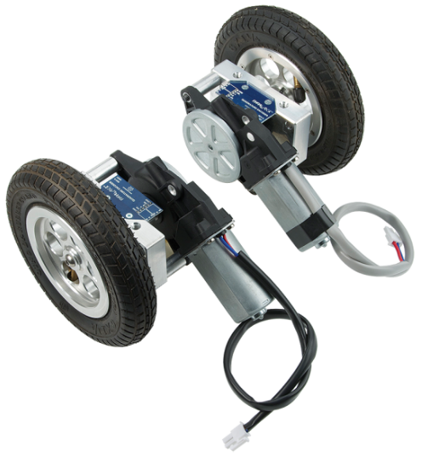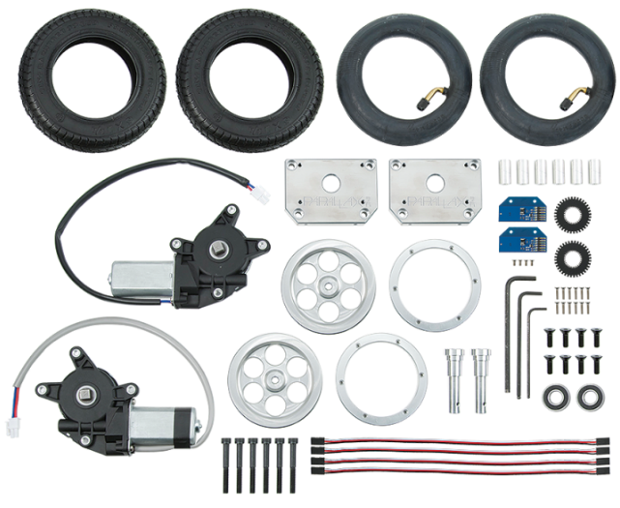
Figure 26 -Swivel wheel by Parallax Inc.

A self-aligning swivel wheel called Caster Wheel Kit Rev.B (web page of the product: https://www.parallax.com/product/28961) is used for the platform side turn moves.

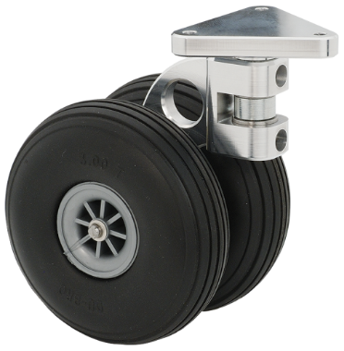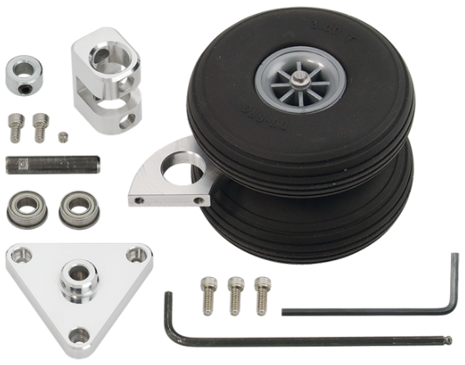
Figure 27 - Swivel wheel by Parallax Inc.

As controlling drivers of a direct current motor the DHB-10 Dual H-Bridge 10 Amp Motor Controller (web page of the product: https://www.parallax.com/product/28231) was used. The supply voltage is 6-24 VDC, and it has two control channels with two motors with current up to 10A. It supports both pulse-width control of the motors and command control.

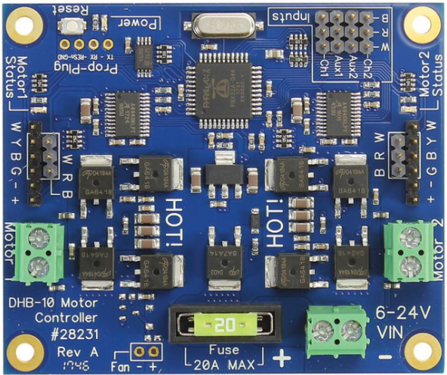
Figure 28-Motor controller by Parallax Inc.

As a control element – microcontroller board Bluno V2.0 by DFRobot (product page: https://www.dfrobot.com/product-1044.html), which includes Arduino Uno and Bluetooth 4.0 module (BLE). Power supply 7-12V, microcontroller - Atmega328, bootloader -Arduino Uno.

Figure 29 - Bluno V2.0 by DFRobot

Bluetooth 4.0 provides considerably reduced power consumption, which is essential for self-contained devices. But considering that some smartphones do not support Bluetooth 4.0, it was decided to install Bluetooth HC06 Module too, in order to allow interaction with smartphones and tablets, which only support old protocols: Bluetooth 2.0/2.1 (product page: http://www.wavesen.com/probig.asp?id=24). Further, it will be possible to use only BLE.
Figure 30 - Bluetooth HC06 Module suitable for Bluetooth 2.0/2.1
In case Bluetooth 2.0/2.1 is sufficient, then instead of Bluno V2.0, Arduino Uno (product page: https://store.arduino.cc/arduino-uno-rev3) or its equivalent can be used.
To power the entire electrical part, the Outdoors YTX7L-BS(GEL) starter battery is used with a rated voltage of 12V and a capacity of 7Ah, the starting current is 85A, and its weight is 2.25 kg.

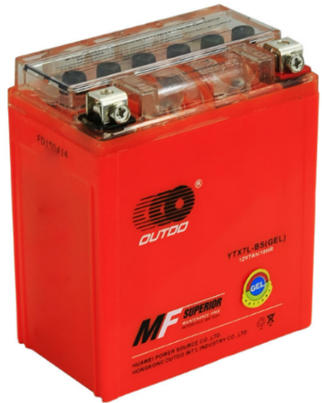
Figure 31 - Accumulator Outdo MF Surerior GEL

    - Platform general design

It was decided to use plywood with a thickness of 8 mm for the working surface of the platform. This choice was made because the plywood is a material that can be easily processed. It has sufficient rigidity and it’s easy to mount the necessary manipulator on it.
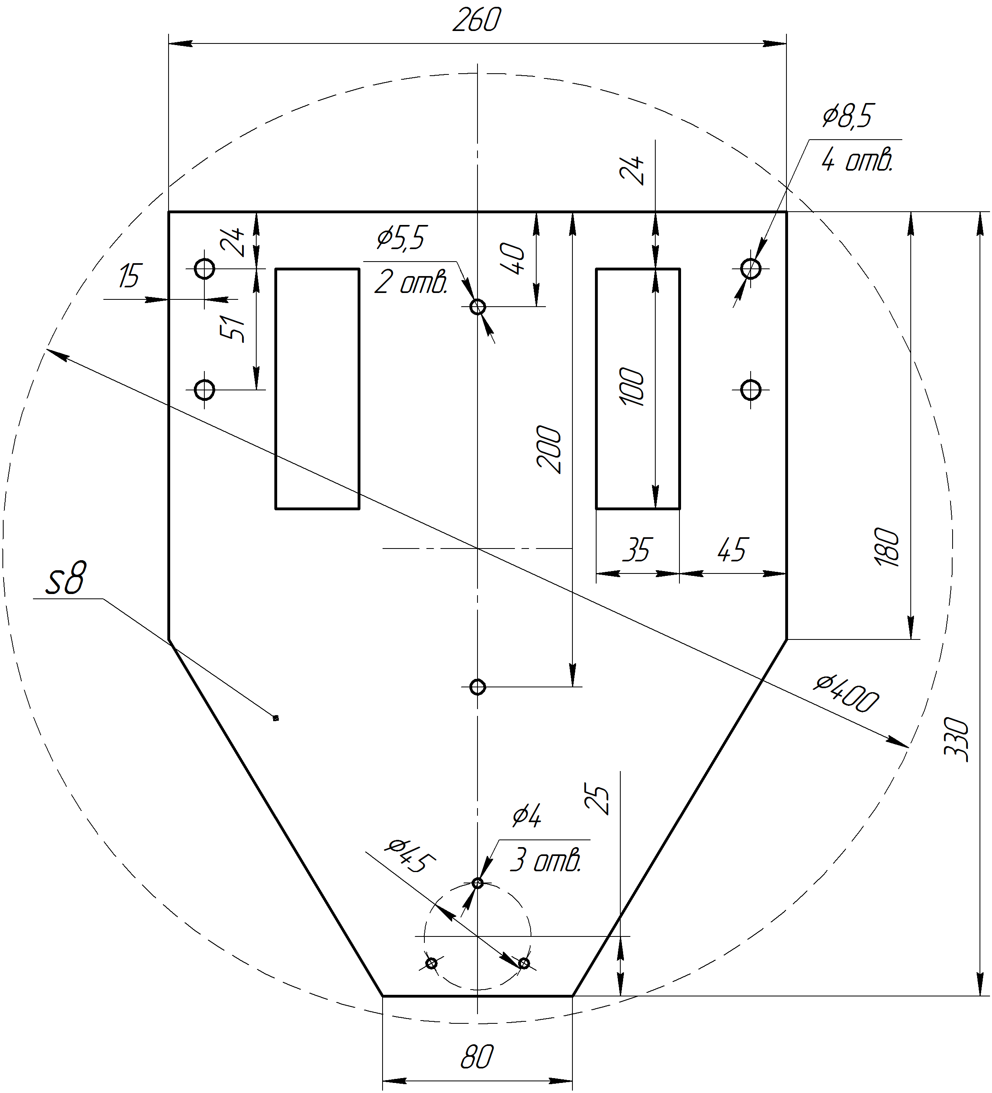
Figure 32 - Sketch of the platform

    - Platform program part and configuration

To implement the program part of the project, a free resource RemoteXY is used. This is a system for developing and using mobile graphical interfaces for operating controllers from a smartphone or tablet.
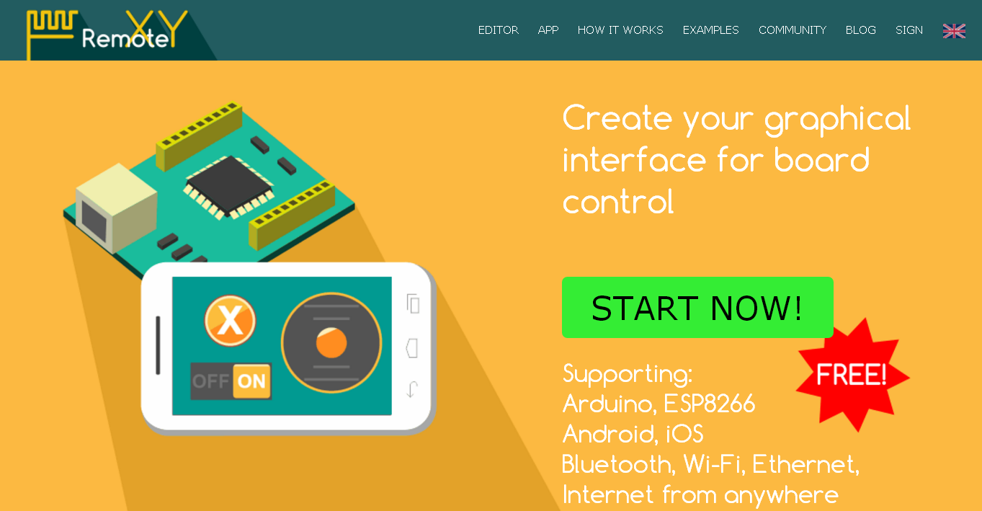
Figure 33 - Free resource http://remotexy.com/en/

This system includes: the editor of mobile graphical interfaces for controllers (available at http://remotexy.com/en/) and the mobile application RemoteXY, which allows you to connect to the controller to display graphical interfaces (can be downloaded from the App Store or Google Play at http://remotexy.com/en/download/).
GUI configuration is stored in the controller and when connected, the GUI configuration is downloaded to the mobile application from the controller. From one single mobile application you can control several devices (there is no upper limit).
The Following methods of connection between the controller and mobile device are supported:
-Bluetooth;
-WiFi - both client and hotspot modes;
-Ethernet within IP address or URL;
-Internet from any point through the cloud server;
Supported mobile operating systems: IOS and Android.

RemoteXY service allows developing any graphical interface by using elements of control, indication and formalization in any their combination. You can develop an interface for any task placing elements on the screen with the use of an online editor.
Having developed a graphical interface, you get the source code of the program for the micro-controller that implements your interface. Source code is a structure for the interaction of your program with elements of control and indication. Thereby, you can easily integrate a control system into the task you develop a device for.

On the resource page (http://remotexy.com/en/) create a graphical interface. To do this choose needed type of wireless connection, controller, Bluetooth module, development environment in Configuration submenu. Then, from Controls menu, drag-and-drop control elements you need to a virtual smartphone’s screen:
Switch - used for turning the platform motion control on and off;
Slider - allows to regulate max platform movement speed;
Button - used to give a warning sound;
Joystick – joystick, which is proportional control element and allows you to transmit to the microcontroller a smooth change of its coordinates in two axes: x and y. The joystick is controlled by a finger by moving its slider within the zone and allows you to smoothly change the value from -100 to 100 for each of the axes. The joystick is additionally equipped with a centering button and accelerometer control (G-sensor).

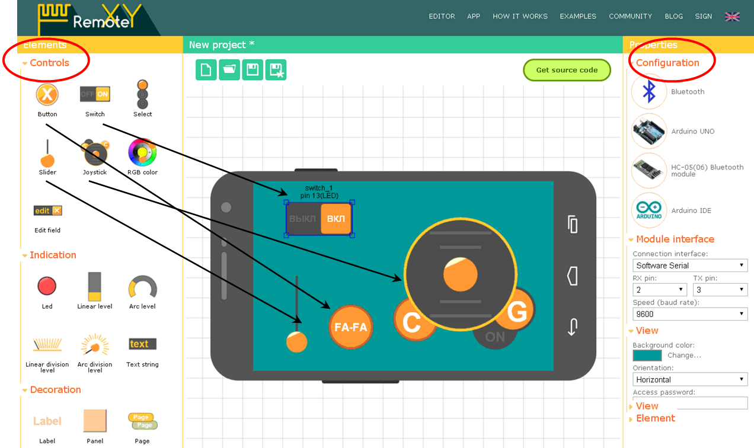
Figure 34 - Creating a graphical control interface

After creating the graphical interface, we get links to download the source code and the RemoteXY library for the microcontroller and the smartphone (tablet) application:
In the source code, after downloading it, we add parts of the code to manage the platform, linking them to the names of the variable elements of the graphical interface. Then we place the components on the platform and connect them electrically. On the platform, we install a switch that disconnects all electronics from the battery.
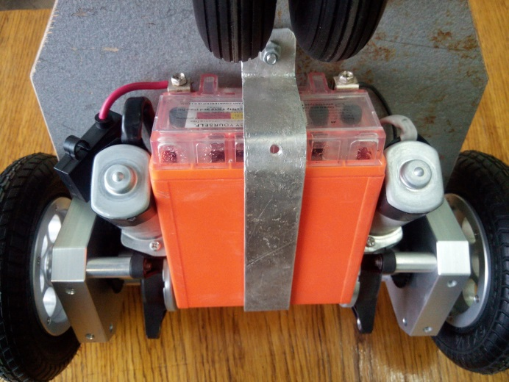
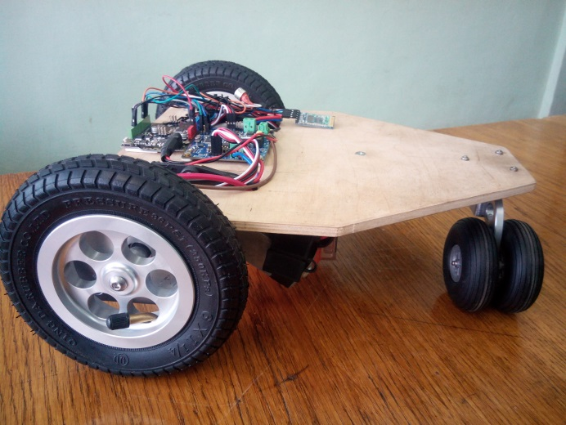
Figure 35 - Appearance of a mobile platform
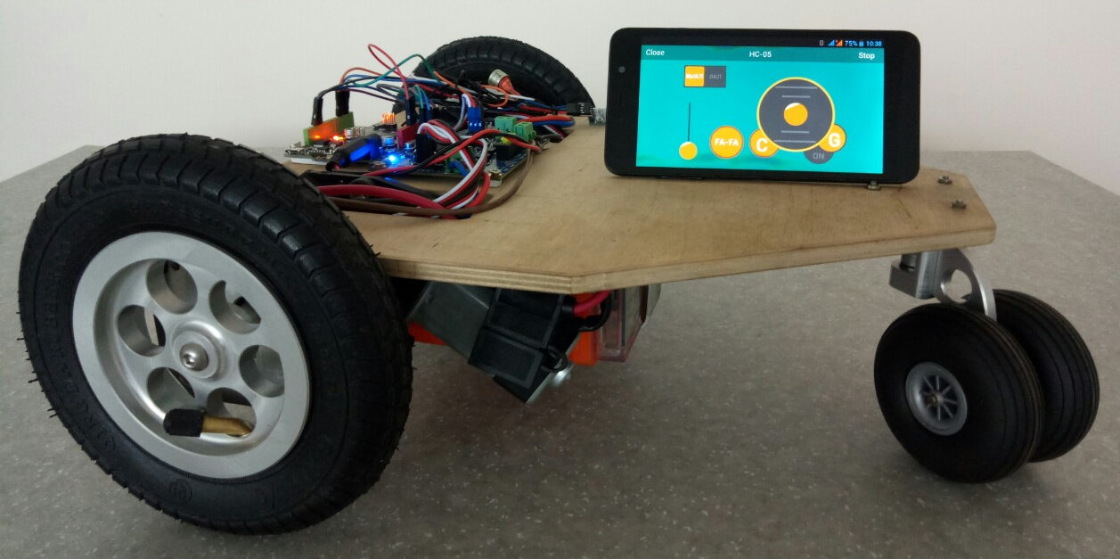
After that, through the USB port using the Arduino IDE, we load the program into the microcontroller and turn on the battery power supply. When the Bluetooth module of the platform and the smartphone is paired, the management interface via Bluetooth will be downloaded to the mobile device from which the platform will be controlled. To control the platform from any mobile device, you need to install the free RemoteXY application (http://remotexy.com/en/download/) on it, turn on Bluetooth and pair with the HC06 Bluetooth module. After starting RemoteXY, select the connected module and the graphical management interface will appear on the screen of the mobile device.

Figure 36 - Mobile platform with smartphone control
See the final version of source code and more detailed description of build process here - http://itm.kpi.ua/proekti-fab-lab/mobilna-platforma-z-keruvannyam-vid-smartfona/

